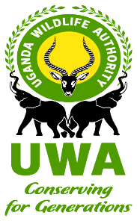
INVESTING IN FORESTS AND PROTECTED AREAS FOR CLIMATE SMART DEVELOPMENT PROJECT (IFPA-CD)

PROVISION OF CONSULTANCY SERVICES TO PREPARE ARCHITECTURAL DESIGNS, COSTED BOQS, SPECIFICATIONS, ENVIRONMENTAL AND SOCIAL MANAGEMENT PLAN FOR THE CONSTRUCTION AND SUPERVISON OF MUPINA AND CHOBE STREAM CROSSINGS IN MURCHISON FALLS NATIONAL PARK
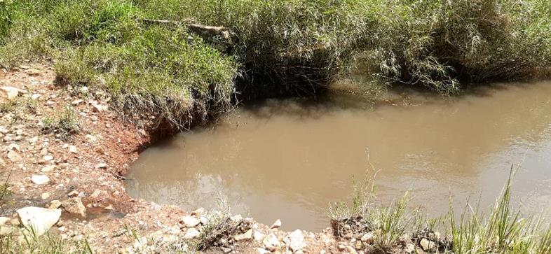

ENVIRONMENTAL AND SOCIAL MANAGEMENT PLAN

DECEMBER , 2025

ACKNOWLEDGEMENT

I hereby declare that this ESMP represent the facts pertaining to the proposed stream crossings construction.

Denis Mayengo Kato
ESIA Practitioner, Reg. No. CC/EIA/211/224

Date: 15/10/2025

Contents
ACKNOWLEDGEMENT 2
List of Figures 4
List of Tables 4
1. INTRODUCTION 1
1.1. Background 1
1.2. Purpose and objectives of the ESMP 1
2. DESCRIPTION OF THE PROJECTs and LOCATION 3
2.1. Mupina stream crossing 3
2.2. Chobe Stream crossing 5
2.3. Proposed stream crossing construction 10
2.3.1. Structural Designs for Mupina and Chobe Stream Crossings 10
2.3.2. Access roads 15
2.4. Construction Method 17
2.4.1. Stream Crossings 17
2.4.2. Access Roads 18
3. ENVIRONMENTAL AND SOCIAL POLICY, LEGAL AND REGULATORY FRAMEWORK 20
3.1. Key Environmental and Social Legal and Policy Frameworks 20
3.2. Policy Framework 20
3.2.1. The Wildlife Policy, 2014 20
3.2.2. The National Environment Management Policy, 1994 20
3.2.3. National Water Policy, 1999 21
3.2.4. Uganda Gender Policy, 2007 21
3.2.5. National Policy on HIV/AIDS and the World of work, 2007 22
3.2.6. National Occupational Health and Safety Policy, 1995 22
3.2.7. The Uganda Forestry Policy, 2001 23
3.2.8. National Land Policy, 2013 23
3.2.9. The National Climate Change Policy, 2015 24
3.2.10. National Employment Policy, 2011 24
3.3. Legal Framework 25
3.3.1. Constitution of the Republic of Uganda, 1995 25
3.3.2. The National Environment Act Cap. 181 25
3.3.3. Water Act Cap. 164 25
3.3.4. Public Health Act Cap . 310 26
3.3.5. The Uganda Wildlife Act Cap. 315 26
3.3.6. The Land Act Cap. 236 26
3.3.7. The Mining and Minerals Act Cap. 159 26
3.3.8. The Employment Act Cap. 226 26
3.3.9. The Occupational Safety and Health Act Cap. 231 27
3.3.10. The Workers Compensation Act Cap. 233 27
3.3.11. Local Governments Act Cap. 138 28
3.4. Regulations 28
3.4.1. The National Environment (Environmental and Social Assessment) Regulations, 2020 28
3.4.2. The National Environment (Audit) Regulations, 2020 28
3.4.3. The National Environment (Noise and Vibrations Standards and Control) Regulations, 2013 29
3.4.4. The National Environment (Air Quality Standards) Regulations, 2024 29
3.4.5. National Environment (Management of Ozone Depleting Substances & Products) Regulations S.I. No. 48 of 2020 30
3.4.6. National Environment (Control of Smoking in Public Places) Regulations, 2004 30
3.4.7. National Environment (Waste Management) Regulations, 2020 30
3.4.8. The Water (Waste Discharge) Regulations, 1998 31
3.4.9. The Employment (Employment of Children) Regulations, 2012 31
3.4.10. The Employment (sexual harassment) Regulations, 2012 31
3.4.11. Murchison Falls Protected Area General Management Plan 2012–2022 31
3.5. The World Bank (WB) Environmental and Social Standards (ESSs) 32
4. ENVIRONMENTAL SETTING 36
4.1. Climate 36
4.2. Geology, soils and Landscapes 36
4.3. Geomorphology and hydrology 37
4.3.1. Mupina stream 37
4.3.2. Chobe stream 37
4.4. Ecosystems and biodiversity 37
4.4.1. Fauna 40
4.4.2. Avifauna 40
4.4.3. Aquatic ecology 41
4.5. Air quality 41
4.6. Noise 41
4.7. Socio-economic Environment 41
4.7.1. Location and Administrative structure 41
4.7.2. Economic activities and sources of livelihood 41
4.7.3. Land tenure and settlement characteristics 41
5. Stakeholder engagement 43
5.1. Introduction 43
5.2. Objectives of stakeholder engagements 43
5.3. Stakeholder Identification and Engagement 43
5.4. Stakeholder concerns 43
6. Impact analysis and mitigation 48
Positive Impacts 48
6.1. Preconstruction phase 48
6.1.1. Market for Construction Materials 48
6.1.2. Destruction of Floral characteristics 48
6.1.3. Disturbance of Wildlife 48
6.1.4. Risk of introduction of Invasive Species 49
6.2. Construction Phase 49
6.2.1. Creation of jobs 49
6.2.2. Creation of business opportunities 50
6.2.3. Improved park management and tourism 50
6.2.4. Skills Development among local population 50
6.2.5. Improved Emergency Response 50
Negative Impacts 51
6.2.6. Sourcing of Construction Materials (murram, gravel and aggregate) 51
6.2.7. Introducing non-native species to terrestrial and aquatic environments 51
6.2.8. Improper management of cut to spoil 52
6.2.9. Improper waste management 52
6.2.10. Loss of vegetation and micro-habitat 52
6.2.11. Poaching 53
6.2.12. Air and dust emissions 53
6.2.13. Noise and vibrations 54
6.2.14. Disturbance and Habitat Alteration 55
6.2.15. Generation of waste water 55
6.2.16. Impacts on Water quality 55
6.2.17. Increase in turbidity of water sources 56
6.2.18. Impacts associated with storage of construction materials including petroleum products 56
6.2.19. Occupational health and safety 57
6.2.20. Risk of fire outbreak 58
6.2.21. Increase of HIV/AIDs and STDs 58
6.2.22. Violence against Children (VAC) 59
6.2.23. Climate Change Impacts 59
6.3. Post construction Phase 59
6.3.1. Improved road network 59
6.3.2. Improper drainage of stormwater from the road 60
6.3.3. Accidents involving wildlife 60
7. ENVIRONMENTAL AND SOCIAL MANAGEMENT AND MONITORING PLAN 61
7.1. Introduction: 61
7.2. Environment and Social Management Plan (ESMP) 61
7.3. Roles and Responsibilities for ESMP Implementation 61
7.4. ESMP Implementation Arrangement 62
7.5. Responsibilities of Stakeholders in Monitoring Project Compliance 62
7.6. Grievance Redress Mechanism 77
7.6.1. Overview 77
7.6.2. Grievance Redress Process 77
7.7. Emergency Response Plan 79
7.7.1. Background 79
7.7.2. Scope of the Plan 79
7.7.3. Legal and contractual requirements 79
7.7.4. Prevention of emergencies 79
7.7.5. Emergency Resources 79
7.7.6. Human Resources 79
7.7.7. Emergency services 80
7.7.8. Contractor’ employees 80
7.7.9. Identification of potential emergency scenarios 80
7.7.10. Emergency Procedures 80
7.8. Traffic Management Plan 81
7.9. Occupational Health and Safety management Plan 82
7.10. Waste Management Plan 84
7.11. Decommissioning/Restoration/Rehabilitation Plan 85
8. ENVIRONMENTAL AND SOCIAL MONITORING PROGRAMMES 86
8.1. Purpose of Monitoring 86
8.2. Scope of Environmental and Social Monitoring 86
8.3. Monitoring Activities and Processes 87
8.3.1. Site Inspection 87
8.3.2. Meetings 87
8.3.3. Monthly Environmental and Social Report 87
8.3.4. Environmental and Social Management Plan Reviews 88
8.3.5. Environmental Compliance Audit 88
8.3.6. Approval of the ESMP Activities 88
9. CONCLUSION 89
References 90
Appendix 91

List of Figures
Figure 2: Locality map for Mupina stream crossing 4
Figure 3: Chobe Stream and the stream crossing 6
Figure 4: status of Chobe Stream Crossing 7
Figure 5: Location of Chobe and Mupina Stream Crossings 9
Figure 6: Structural design for Mupina stream crossing 10
Figure 7: Structural design for Chobe stream crossing 12
Figure 7: Artistic Impressions of the proposed Chobe stream crossing 13
Figure 8: Artistic Impressions of the proposed Mupina stream crossing 14
Figure 9: Soils around Murchison Falls National Park (Proposed Chobe and Mupina stream crossings) 37
Figure 10: Environmental setting around Mupina stream 39
Figure 11: Environmental setting around Chobe stream crossing 40
Figure 12: Consultations with MFNP field staff at Mubako head offices 45
Figure 13: Consultation with the Chief Warden Murchison Falls Conservation Area held at his office in MFNP 46

List of Tables

Table 3-1: Table Regulatory noise limits (Uganda) 29
Table 3-2: Applicability of the World Bank ESS to stream crossings construction 32
Table 4-1: Identified tree species around Mupina stream crossing 38
Table 4-2: Identified tree species around Chobe stream crossing 40
Table 5-1: Views and concerns raised by stakeholders 44
Table 7-1: Environmental and Social Management and Monitoring Plan for Mupina and Chobe stream crossings construction 65

INTRODUCTION

Background
Uganda Wildlife Authority (UWA) is a semi-autonomous statutory body established in 1996 by an Act of Parliament, Uganda Wildlife Statute 1996 (now Uganda Wildlife Act Cap.315), and is responsible for managing the Protected Areas of Uganda, including 10 National Parks, 12 Wildlife Reserves, 13 Wildlife Sanctuaries and 5 Community Wildlife Management Areas. Murchison Falls National Park is among the Protected Areas managed by UWA.

Murchison Falls National Park lies at the northern end of the Albertine Rift Valley, where the sweeping Bunyoro escarpment tumbles into vast, palm-dotted savanna. UWA has continuously registered operational challenges due to shrinking river crossing resulting from flooding, blocked culverts and bridges, and collapse of river banks that has necessitated the rehabilitation and construction of the stream crossings.

Chobe and Mupina stream crossings are part of many strategically important bridges that were developed at the behest of the UWA for the sake of better connectivity and safety along road corridors that are yet to undergo routine rehabilitation. The bridges along unpaved park roads are very old, with damaged structures, insufficient width and load carrying capacity rendering them generally unsafe for vehicles to ply over it. To render the services uninterruptedly repair and rehabilitation of these two stream crossings is not a feasible option and need to be replaced with new stream crossings capable of adequate width to handle anticipated traffic (in terms of load). Uganda Wildlife Authority (UWA) has obtained funding from the World Bank to design, and reconstruct Mupina and Chobe stream crossings to facilitate movement for UWA operations and other tourism activities.

Flexihome Consulting Engineers were contracted to design the proposed stream crossings and prepare Environmental and Social Management Plan (ESMP) for the reconstruction of Mupina and Chobe stream crossings in the Murchison Falls National Park. This document therefore presents the ESMP to guide UWA and stakeholders on the sound management of stream crossings construction and rehabilitation.

Purpose and objectives of the ESMP
The purpose of this Environmental and Social Management Plan (ESMP) is to provide objectives, strategies and procedures for ensuring that the Construction of Mupina and Chobe stream crossings meets the relevant World Bank Environmental and Social Standards (ESSs), the World Bank EHS guidelines and applicable legal and regulatory requirements of Uganda. The ESMP forms an integral part of UWA Management system and applies to all activities during the construction of the stream crossings.

Specifically, this ESMP is intended to attain the following objectives:
- Provide a framework for integration of social and environmental aspects at all stages of project planning, design, execution and operation.
- Enhance positive social and environmental impacts of the project and avoid/minimize or manage any potential adverse impacts.
- Ensure transparent and effective prevention, minimization, mitigation, off-setting, enhancement and monitoring measures to manage the environmental and social impacts associated with construction of the stream crossings;
- To achieve environmental and social performance that meets applicable national and international standards (the World Bank ESSs).
- Defines a mechanism for engaging and effectively communicating with stakeholders in the management of the Project’s environmental and social issues;
- To streamline communication and operational procedures regarding environmental, health, safety and social compliance for easy monitoring and reporting purposes.
- Provides a framework for managing the environmental controls and processes implemented by the Contractor’s sub-contractor(s) in carrying out their respective responsibilities in relation to the Project.

DESCRIPTION OF THE PROJECTs and LOCATION
This section presents a description of the stream crossings project to be rehabilitated and describe their location to lay foundation for assessing impacts likely to result from the different phases of the project.

Mupina stream crossing

Mupina stream crossing is located in the Murchison Falls National Park, providing river crossing to Kisangani Sector of the Park. This is located deep inside the park with at a distance of about 100km from the nearest community.
The existing stream crossing is located within the Murchison Falls National Park in an area commonly known as the Heart of Murchison around coordinates 2.24815°N, 31.86120°E. The current stream crossing is a gravel road and has a span of about 6m with five 1200 mm concrete culverts installed for drainage. The stream crossing has been heavily eroded by the flowing water, with observed backflow.
The stream crossing consists of small culverts with damaged walls forming debris that hold river load thus blocking the direct flow of water. Following heavy downpour, the river floods at the road crossing due to blockage of the path by plants grown on the banks, and narrowing culvert path. The existing culvert height is lower than observed flood level and the river form pools both upstream and downstream to the bends.
Mupina stream is prone to flooding and it often times bursts its banks. However, flood levels recede quickly due to the fast-flowing nature of the river. The Mupina stream discharges directly into the greater Mupina River (Figure 2) which then pours into the Victoria Nile. The water levels within the river are highly seasonally variable with high levels observed during rainfall events, which is an important factor to be considered in the design.
An on site field visit was conducted during the dry season and it was noted that at the point of the crossing, the stream has a variable width about 9- 12m wide and 1m deep, and relatively fast flowing with a velocity of 0.5-0.8 m3 /s (from field measurements). There was a lot of vegetation growing within the river profile also contributing to the flooding of the crossing during the rainy seasons. The river greatly meanders with a lot of vegetation growing along the banks. Backflow was also observed which has led to erosion of the crossing. There was also evidence of sediment deposition like rocks, pebbles and river sand along the river banks.

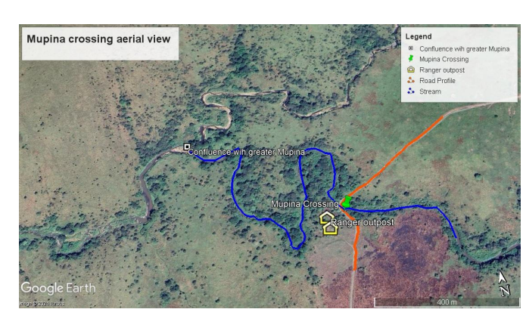

Figure 2: Locality map for Mupina stream crossing

Chobe Stream crossing

Chobe Stream Crossing is located within Murchison Falls National Park, providing stream crossing from Chobe sector to Wankwar sector of the Murchison Falls National Park. This is located close to Chobe Safari Lodge and the nearest community is located about 20km away from the project site.
The stream crossing consists of three lines of small culverts with some plant growth in the river bed narrowing water path at the road crossing. Following heavy downpour, the river floods due to blockage of the path by plants in the banks, siltation and narrow culvert.

River Chobe is a small stream flowing through the Murchison Falls National Park greatly meandering with a variable width of 3.5m downstream to 8m downstream (Figure 3). The river banks are overgrown with riparian vegetation and trees. The stream flows at a low level with a shallow depth varying between 0.5 - 0.7 m (higher downstream). During extreme rainfall, the water levels can rise as high as 1m above the crossing causing it to be submerged, according to local rangers. Backflow from the wetland downstream of the crossing also tends to occur.
An on site field visit was conducted during the month of September which is a dry season and the river was relatively slow flowing with a velocity of about 0.12 m/s during low flow as estimated using the floating object method. The estimated discharge at the time of the visit was 0.8 -1.2m3/s (using the floating objective method). The river eventually discharges into the Victoria Nile. During the construction and rehabilitation phase, murram shall be sourced from Chobe borrowpit which is located 1km away from the Chobe stream crossing which shall be accessed through the Chobe-Wankwar track. The stream crossing is utilised for both UWA operations and tourists connecting to Wankwar sector of the park.

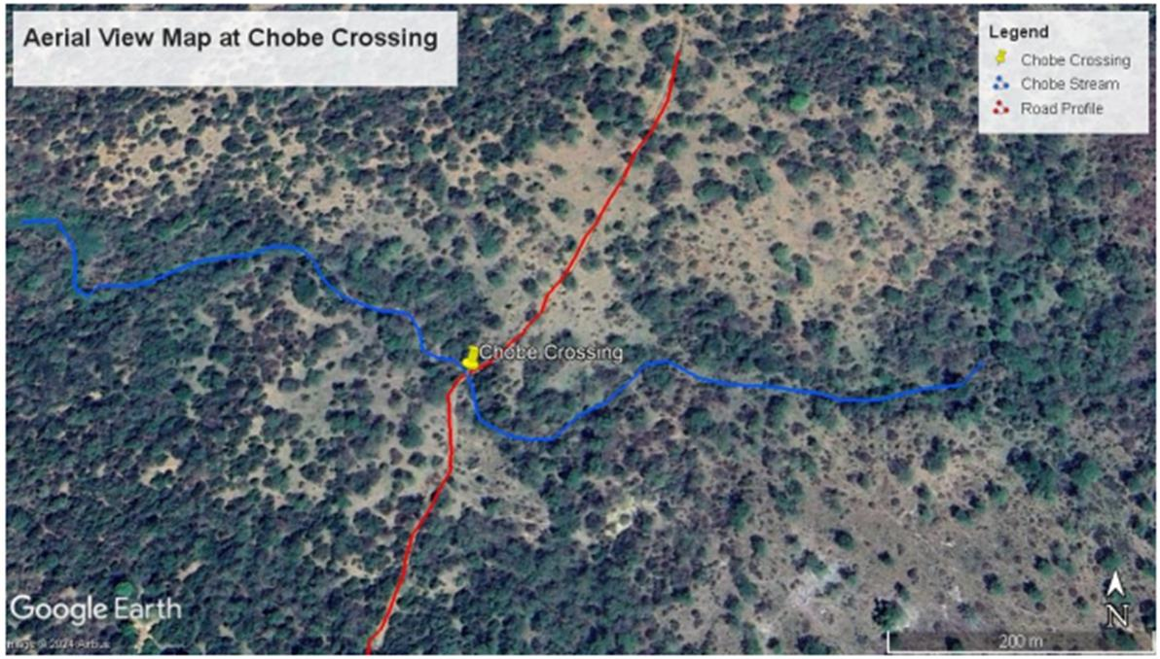

Figure 3: Chobe Stream and the stream crossing

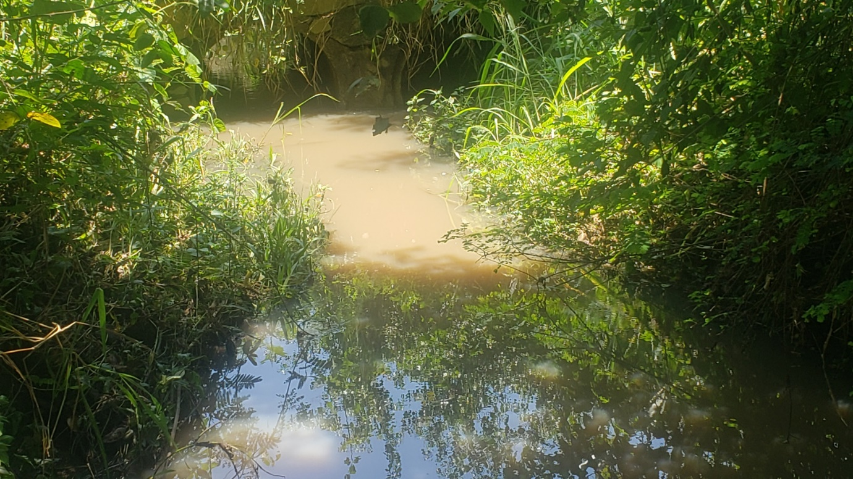
Figure 4: status of Chobe Stream Crossing

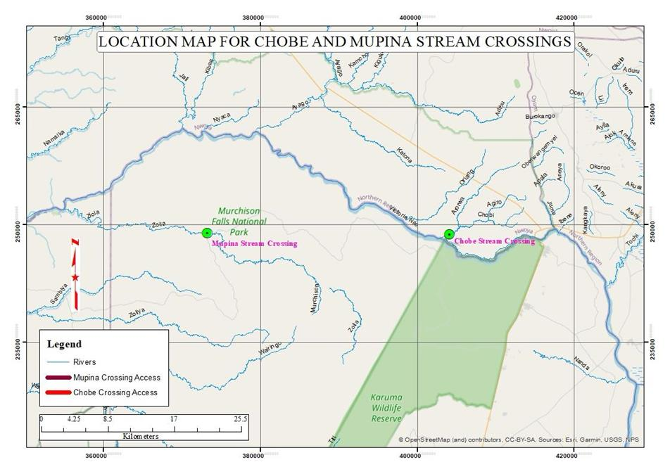
Figure 5: Location of Chobe and Mupina Stream Crossings

Proposed stream crossing construction
The stream crossings are to be constructed to allow the smooth flow of the water downstream following heavy downpour in the MFNP whilest sustaining UWA and the related tourism operations in terms of logistical movement across the stream crossing using trucks and tourist buses of different capacities as per the stream crossings designs. This will necessitate reconstruction of better stream crossings with clear water path and good strength to allow for safe and uninterrupted crossing at these river sections during different seasons of the year especially during the rainy season.

Structural Designs for Mupina and Chobe Stream Crossings

As indicated in Fig.7 and Fig. 8 below, both Mupina and Chobe stream crossings are proposed to be constructed with box culverts crossing structure. The Chobe stream (Inlet width = min. 3.5m, Outlet width = min. 5m) is smaller than the Mupina stream (Inlet width = min. 7.5m, Outlet width = min. 10.5m). The 3D impressions provided under Fig. 7.. Based on the structural design components as described below, Mupina stream crossing is wider and higher than Chobe stream crossing.

Figure 6: Structural design for Mupina stream crossing
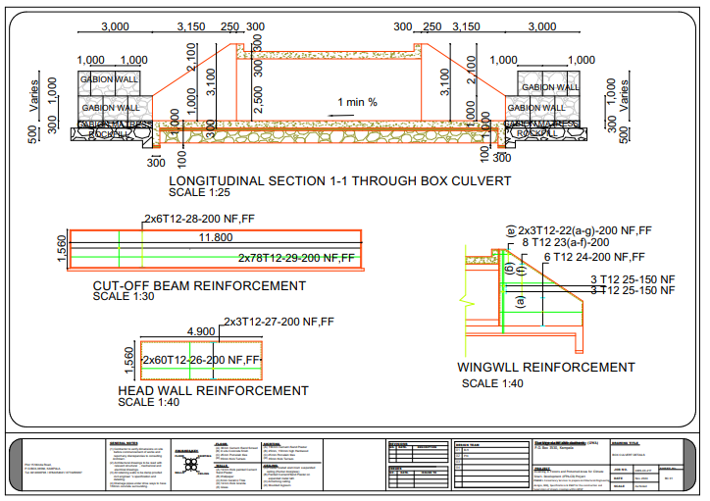
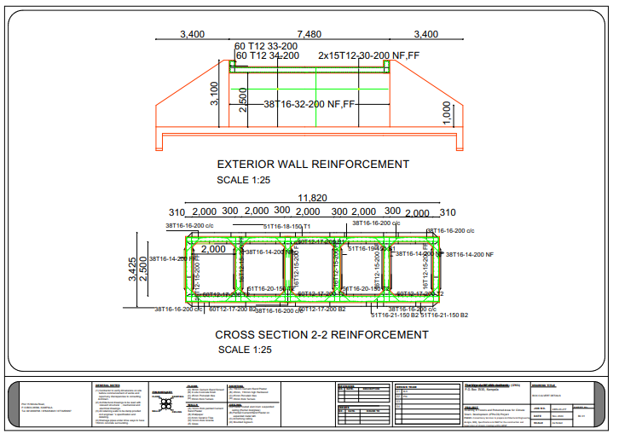

Figure 7: Structural design for Chobe stream crossing
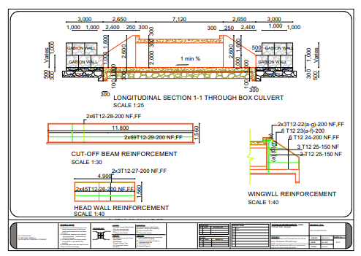
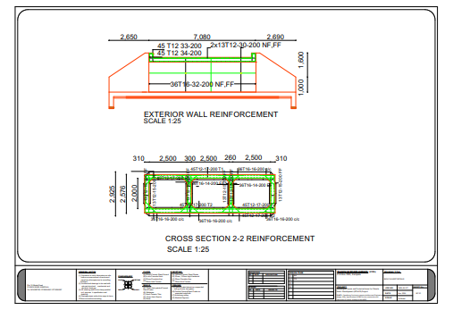

Figure 7: Artistic Impressions of the proposed Chobe stream crossing

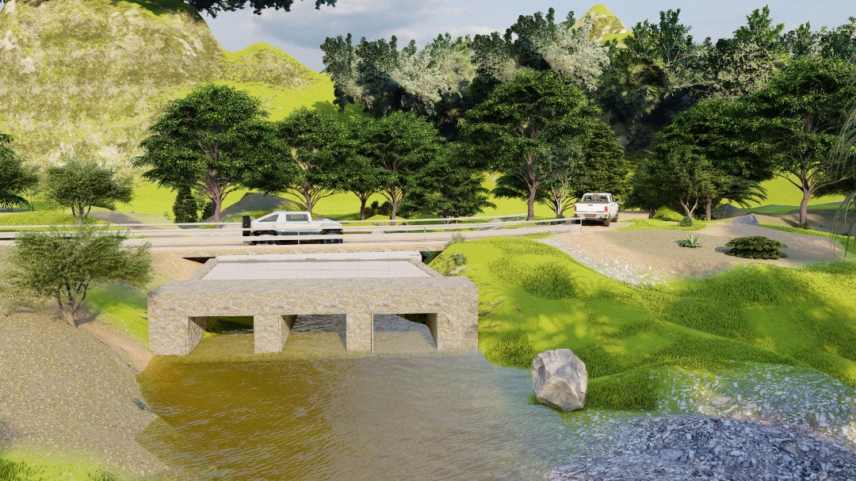

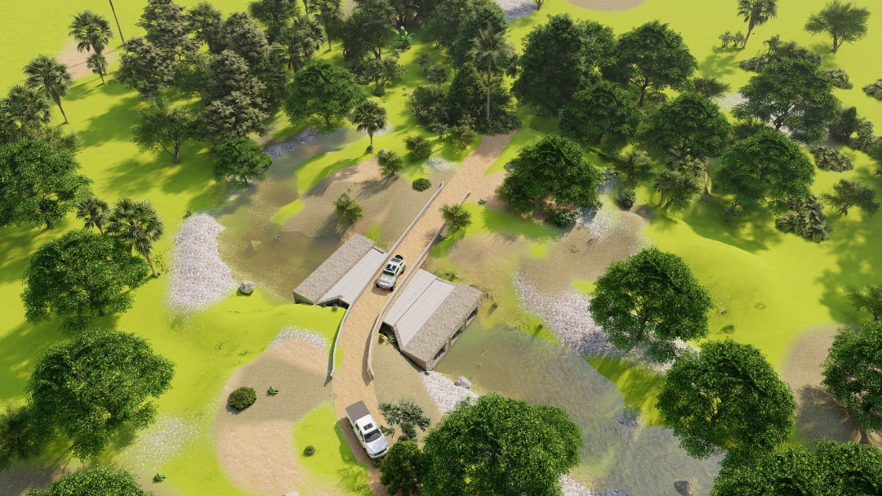

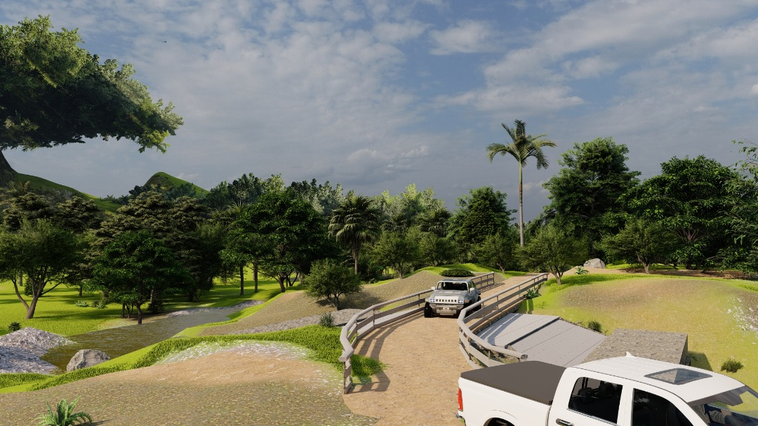
Figure 8: Artistic Impressions of the proposed Mupina stream crossing
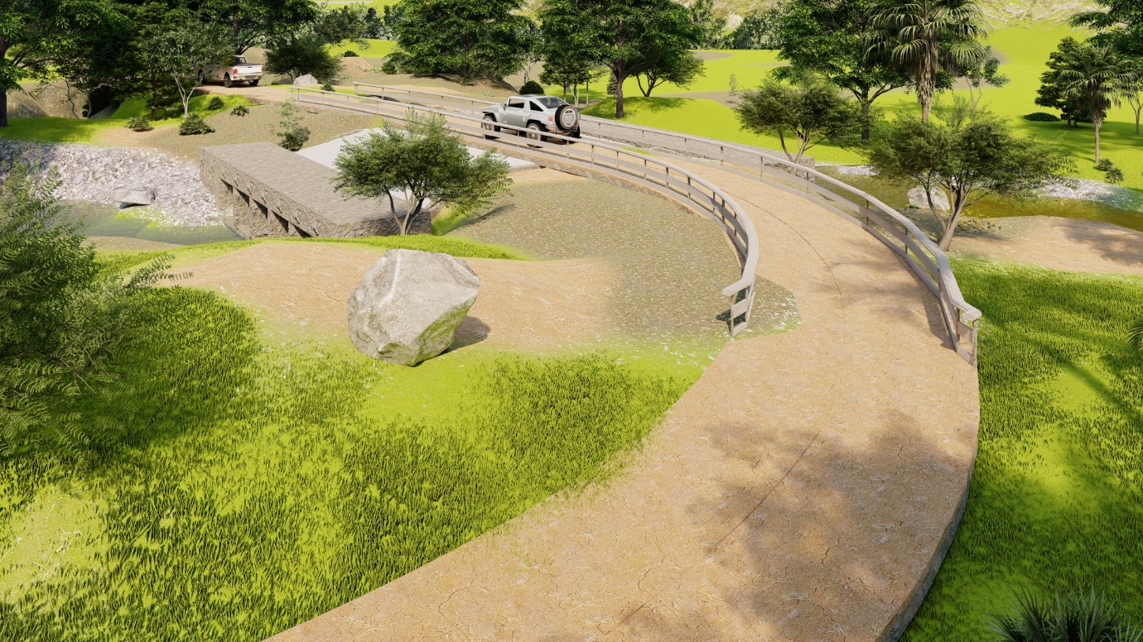
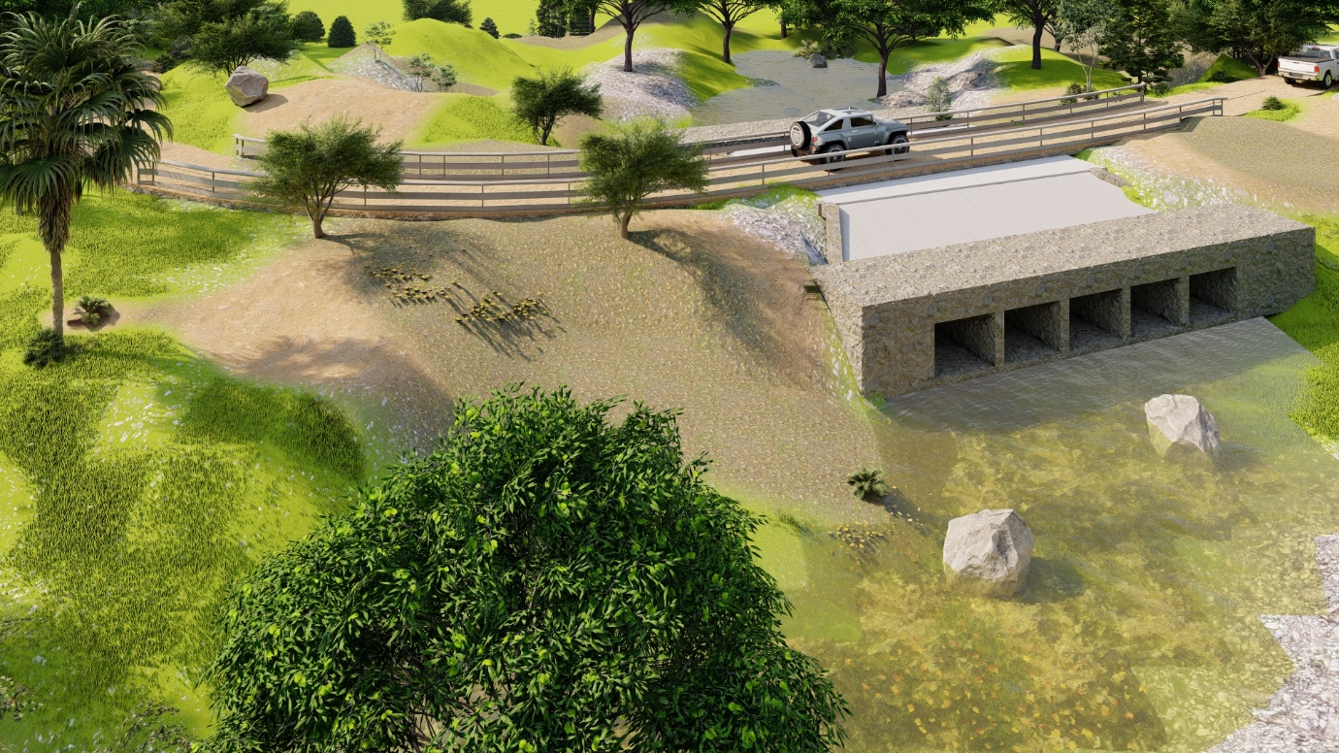
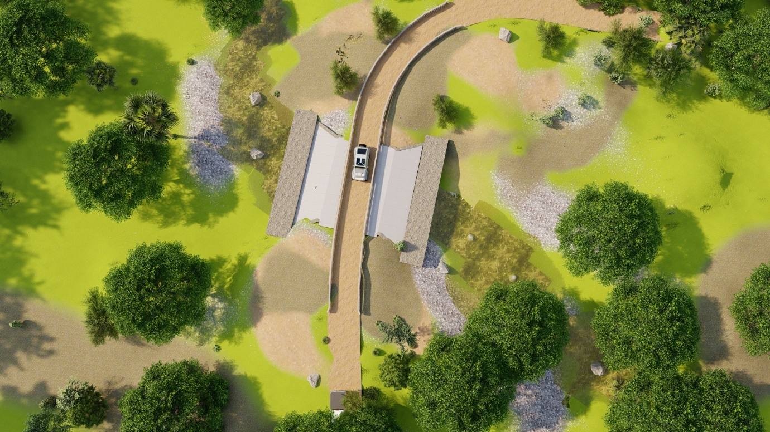

Access roads
The access roads have been designed basing on the Ministry of Works and Transport Geometric design manual and Gravel pavement design manual, Vol 3 . According to the reviewed design manuals, the average width of a truck/bus is 2.45m and the length is 7.2m. Therefore, the underlisted length and width of vehicles fits within the range. The following criterion as summarised in the table below, has been adopted for the design of the access roads. In high fill sections, Guardrails shall be provided for safety and hence the Shoulder of 0.25m on either side.

Alignment (Geometric Design Considerations | - Maximum length of trucks and tourist vehicles expected is 7.5m.  - Maximum Width of trucks and tourist buses expected 2.6m wide.  - Speed is designed at Max 40km/hr.
Alignment (Geometric Design Considerations | Road Design class is LVSR 1  - Carriage way width- 3.5m  - Shoulder width – 0.25m  - Number of Lanes- 1  - Camber (Slope) – 2.5%
Alignment (Geometric Design Considerations | Sub grade– (S3)  - Climatic Zone – Wet Climate zone (N<4) The project's environmental conditions were categorized under the Wet Climate Zone (N<4), a determination made by analyzing regional rainfall data against the thresholds established in the Uganda Road Design Manual. With an average annual rainfall undoubtedly exceeding the 800 mm benchmark for Climatic Zone 2 (High Rainfall Area), the design necessitated specific provisions to manage moisture.
Pavement Design Considerations | Design Parameters  - Access roads to be used for administrative purposes along tourism tracks and classified as Low Volume Road  - Maintenance culture and Budget – Sealing required to reduce gravel loss  - Pavement Details D  - 30mm Double Surface Dressing  - 200mm Gravel G30  - 200mm Gravel G15  - Fill layers Gravel G7  - Swamp Treatment below Drainage Structure
Design Codes | - Uganda Road Design Manual Section 7.  - Uganda Road Design and Construction Manual, Vol. V, Low Volume Sealed Roads

Construction Method
The envisaged construction methods to be used during the execution of the works are discussed below.

Stream Crossings
The major categories of the works included for stream crossings are:
➢ Site clearance and setting out;
➢ Culvert installation.
➢ Gravelling

Site clearance and setting out
The displacement method of constructing stream crossings is proposed to be used. This will involve clearing the site of vegetation to disposal and removal of top soil to stock pile for reuse for landscaping. Site clearance activities will involve use of earthmoving equipment such as dozing equipment and a grader machine to attain a firm ground surface.

Dewatering of the work area
This will be done by use of a water pump of suction capacity able to remove the water from the working area. The pumped water will be discharged back into the stream water way.

Excavation works and hardcore bed
Excavation of 1m shall be done to allow for a hardcore bed using an excavator. The excavated area shall be aligned using a dumpy level and strings to ensure proper alignment.

Box Culvert installation
Box culverts shall be constructed from cast-in-situ reinforced concrete as per the specifications.

Stone Masonry works
Stone masonry works comprising of stones (Hardcore), cement and sand mortar material shall be used to build cut off drains at the sides of the access road embarkments. These works shall be undertaken by masons, casual laborers and will require simple hand tools with the supervision of the site engineer.

Backfill over the box culverts
The fill will comprise freely draining gravelly fill as per the specifications in the drawings. This will be done in layers, moistened and compacted to achieve the maximum dry density as specified. In-situ density tests using a Troxler shall be carried out to ensure the compaction is achieved. The following equipment are required during this operation and they include; tipper trucks, water bowser, grader and vibro compactor.

Pavement layers
The pavement layers specified in the design which are a 30mm Double surface dressing, 200mm G30 subbase, 200mm G15 subgrade and G7 fill material. The material shall be dumped using tipper trucks, watering using water bowser and vibro roller to enhance stability by rolling thoroughly. Quality assurance shall be done in form of insitu compaction tests using Troxler to ensure the specified density is achieved for the various pavement layers. Competent banks men shall be deployed to control plant/vehicle movement.

Ancillary Works
These will include installation of guardrails and night driving delineators as well as information / traffic signs as per the drawings and specifications.

Access Roads
The major categories of the works include:
- Site clearance and setting out
- Earthworks including excavation and backfilling
- Road Works
- Ancillary Works
Site Clearance
This will involve clearing the site of vegetation to disposal and removal of top soil to stock pile for reuse for landscaping. Site clearance activities will involve use of earthmoving equipment such as dozing equipment and a grader machine.

Earth Works
Earthworks shall consist of excavation, backfilling and compaction.
Major earthworks will be carried out using heavy equipment. The minimum equipment to be used includes the following:
- 20 tonne tipper trucks.
- Wheel loader.
- Excavator.
- 15-tonne roller.
- Back hoe.
- Water bowser.

Pavement layers (Road works)
The pavement layers specified in the design which are a 30mm Double surface dressing, 200mm G30 subbase, 200mm G15 subgrade and G7 fill material. The material shall be dumped using tipper trucks, watering using water bowser and vibro roller to enhance stability by rolling thoroughly. Quality assurance shall be done in form of in-situ compaction tests using Troxler to ensure the specified density is achieved for the various pavement layers. Competent banks men should be deployed to control plant/vehicle movement.

Ancillary Works
These will include installation of guardrails and night driving delineators as well as information / traffic signs as per the drawings and specifications.

Proposed manpower for the construction works.
Construction labor force will comprise of both skilled and unskilled man power. For each project site, the skilled manpower shall comprise 10 workers including the Environmental specialist, Site fore man, Site survey, Health and Safety expert among others and the unskilled man power shall comprise of 15 workers to serve as casual labourers. The contractor will be encouraged to source the unskilled man power from the neighboring community. Furthermore, both skilled and unskilled man power shall camp outside Murchsion Falls National Park and these shall be ferried regularly from the camp to the project sites and hence no workers’ camp shall be put in place within the park.

ENVIRONMENTAL AND SOCIAL POLICY, LEGAL AND REGULATORY FRAMEWORK
This section presents a synoptic review of the policies and regulatory framework enforcing standards guiding action detailed in this ESMP

Key Environmental and Social Legal and Policy Frameworks
This chapter discusses policy, legal and institutional framework within which the Environmental and Social Management Plan has been prepared. The proposed stream crossings construction will have significant impacts on the environment from a number of construction activities like clearing and grabbing, coffer dam creation, deposition of murram material in the river, opening up of borrow pits, and stock piling areas. These impacts will therefore have both negative and positive impacts on the environment and social systems in which they are to be located. Uganda has various laws, policies and institutions set up to govern the management of its natural environment as discussed below.

Policy Framework

The Wildlife Policy, 2014
The Uganda Wildlife Policy is a national policy with a sectoral approach. The goal of the Policy is to conserve wildlife resources of Uganda in a manner that contributes to the sustainable development of the nation and the well-being of its people.

As a source of economic benefit, wildlife will be protected to enhance community livelihoods and local community will be involved in the management of wildlife and protected areas. Central and Local Government participation will be enhanced in decision making on activities impacting wildlife management. Community conservation initiatives will be promoted through alternative livelihood improvement projects.

The policy promotes sustainable management of wildlife in protected areas through restoration of all degraded wildlife protected areas, environmental impact assessments, environmental audit, ecological research and monitoring, inspection, and institutional capacity building. The policy aims to promote sustainable wildlife utilization programs as an incentive for wildlife management on private land. The policy further considers collaboration between wildlife, forestry and wetland management institutions and Local Governments to effectively manage wildlife and to conserve wildlife species in wetlands, forest reserves and private land. Management of protected areas will be carried out in accordance with National Protected Area Systems Plan.

Any disturbance associated with the stream crossings construction will be mitigated and restored as guided by the policy and plan’s provisions.
The establishment of the proposed construction and rehabilitation of the stream crossings shall ensure improved management of the park. This is in line with the requirements of this policy.

The National Environment Management Policy, 1994
This policy aims to promote sustainable economic and social development while being mindful of the needs of the future generations. This ESMP is one of the vital tools considered necessary to ensure environmental quality and resource productivity on long-term basis. It calls for integration of environmental concerns into development policies, plans and projects at national, UWA and local levels.
The policy requires projects likely to have significant ecological or social impacts to undertake an Environmental Assessment before implementation. This is also reaffirmed in the National Environment Act Cap. 181 which makes this assessment and plans necessary for a similar project such the stream crossings Construction.

The ESMP presents impacts associated with the proposed stream crossings construction as well as proposes mitigation measures to be implemented to minimize, mitigate and manage aspects associated to ensure accepatable changes in the environment.

Therefore, undertaking this study ensures that the project poses no or minimal impacts on the environment for sustainable development.

National Water Policy, 1999
A key objective of this policy is to guide development and management of water resources in Uganda following an integrated and sustainability concept so as to secure and provide water of adequate quantity and quality for all social and economic needs, with full participation of all stakeholders and mindful of the needs of future generations.
The policy was set to:
- Promote rational use of water.
- Promote provision of safe water supply for domestic use.
- Promote orderly development and use of water resources for purposes other than domestic including transport or navigation.
- Control pollution of any water system as this would impact on both aquatic life and impact negatively on public health.

The policy is relevant where project development could impact the quantity and quality of water resources such as streams, rivers, underground reserves among others that are within the protected area.The proposed stream crossings construction are likely to affect water resources in terms of altering water quality from improper management of construction activities. Construction activities will be monitored to ensure effective implementation of suggested mitigation measures to limit effects water resources as a result of project activities.

Uganda Gender Policy, 2007
The overall goal of this policy is “to achieve gender equality and women's empowerment as an integral part of Uganda's socio-economic development,” and its main purpose is “to establish a clear framework for identification, implementation and coordination of interventions designed to achieve gender equality and women's empowerment in Uganda”. The policy is a guide to all stakeholders in planning, resource allocation, implementation, monitoring and evaluation of programs with a gender perspective.
The specific objectives of the Gender Policy are to:
- Promote gender-responsive sub-sector policies, programs and plans;
- Promote gender-responsive service delivery;
- Enhance equality of opportunities between women/girls and men/boys in all activities; and
- Commit adequate resources to gender-responsive activities within all projects.

The policy requires that, for adequate implementation of gender aspects, there is a need for the Contractor(s) to emphasize gender equality through gender sensitization and awareness as well as construction of gendersensitive sanitary facilities and enhance equal employment opportunities to both men and women.

National Policy on HIV/AIDS and the World of work, 2007
The main goal of the National Policy on HIV/AIDs and the World of Work is “to provide a frameworkfor prevention of further spread of HIV and mitigation of the socio-economic impact of HIV/AIDs within the World of work in Uganda” with some of the policy objectives including:
- To provide guidelines for employers, workers and the government on prevention, management as well as mitigation of the impacts of HIV/AIDs within the world of work.
- To provide guidelines for employers, workers and the Government to eliminate stigma and discrimation based on perceived or real HIV status within the World of work.
- To provide a framework for monitoring and evaluating the effectiveness of measures taken to combat HIV/AIDs within the world of work.
- To provide a framework for monitoring and evaluating the impact of HIV/AIDs within the world of work and;
- To promote care, treatment and support for people living with HIV/AIDs within the world of work.
A total of 25 workers will be expected to be employed at each site during the construction sites, and they are likely to be exposed to an environment that encourages the spread of HIV/AIDs and other sexually transmitted diseases (STDs). The strategies to fulfil this policy’s objectives must be incorporated throughout the project’s life cycle.

The contractor(s) shall avail and display information regarding HIV/AIDs prevention around the construction site as well as carry outsensitization and awareness campaigns against the spread of HIV/AIDs amongst all employees.

National Occupational Health and Safety Policy, 1995
The policy seeks to:
- Provide and maintain a healthy working environment.
- Institutionalize Occupupational Health and Safety (OHS) in the road-sector policies, programs and plans.
- Promote efficient road safety management practices.
- Contribute towards safeguarding the physical environment.

The OHS Policy Statement is guided by the Constitution of the Republic of Uganda and other global, national and sectorial regulations and policies. The Statement also takes into recognition of the Transport Sector Policy and Strategy Paper, and the Health Sector Strategic Plan, all of which aim to improve the quality of life for all Ugandans in work environments.

This policy applies to the construction of stream crossings and the contractor(s) shall ensure that safety and health strategies are put in place at both project sites during the construction phase. Workers will be protected from work related hazards. The designs of the stream crossings shall cater for installation of guard rails to protect from accident diversion into the river course.
The policy will be relevant in provision of mitigation measures that will protect workers from health and safety impacts associated with the activities at the construction sites for instance through the provision of adequate personal protective equipment (PPE) to all workers by the contractor(s).

The Uganda Forestry Policy, 2001
This policy outlines guiding principles for the management of forest resources, including conservation and sustainable management. It also outlines strategies for the management of forest resources that include social and environmental impact assessments for commercial forest plantations and forest-product-producing industries.

The overall Vision of the present cross-sectoral Forest Policy is: “A sufficiently forested, ecologically stable and economically prosperous Uganda”. Part 2 concerns Guiding Principles for the Forest Sector building on the government's national development priorities of poverty eradication and good governance. The Forestry Policy is consistent with the national objectives and directive principles guiding sustainable development found in the Constitution and Vision 2015: Article XIII (Protection of Natural Resources) regarding the protection of important natural resources on behalf of the people of Uganda; Article XXVII (The Environment) regarding: the needs for sustainable management of land, air and water resources; the use of natural resources to meet development and environment needs; the
promotion of sustainable energy polices; the creation of parks and reserves for conservation of natural resources; the protection of biodiversity. The Guiding Principles of the present Policy are, inter alia: Conservation and Sustainable Development; Livelihoods and Poverty; Biodiversity and Environmental Services; Gender and Equity; Cultural and Traditional Institutions; Forestry Valuation; Partnership in Governance dealing with the role of central government, local government, private sector, local communities and farmers, role of NGO’s. effort will b undertaken to limit tree clearance as a result of project activities.

Material sources will be those operated in an environmentally sound manner and approved before operations and supplies to the project. Mitigation measures have been suggested on minimisation of habitat disturbance, implementation will be monitored to ensure effectivenss .

National Land Policy, 2013
The overall goal of this policy is “To ensure an efficient, equitable and optimal utilization and management of Uganda’s land resources for poverty reduction, wealth creation and overall socio-economic development.”
Construction and rehabilitation of the stream crossings considers the objectives of this policy, including, among others;
- To ensure sustainable utilization, protection and management of environment, natural and cultural resources on land for national socio-economic development.
Sustainable, equitable and integrated utilization of natural resources, like land on which the stream crossings are to be constructed, are essential for natural, social and economic development.
The policy emphasizes, among others, environmentally friendly practices during the construction and rehabilitation of the proposed stream crossings.

The National Climate Change Policy, 2015
The National Climate Change Policy of Uganda aims to address the challenges of climate change and promote sustainable development. The policy focuses on the following key areas:

1. Mitigation: Uganda aims to reduce greenhouse gas emissions through various measures such as promoting renewable energy sources, energy efficiency, and sustainable land use practices. The policy encourages the use of clean technologies and the development of low-carbon industries.

2. Adaptation: The policy emphasizes the need to adapt to the impacts of climate change, particularly in vulnerable sectors such as agriculture, water resources, and health. It promotes the integration of climate change considerations into development planning and infrastructure projects to enhance resilience.

3. Capacity building: The policy recognizes the importance of building institutional and individual capacities to address climate change. It aims to strengthen the capacity of government institutions, civil society organizations, and communities to effectively respond to climate change challenges.

4. Research and knowledge management: The policy emphasizes the need for scientific research and knowledge management to inform decision-making and policy formulation. It encourages the generation and dissemination of climate change data, information, and research findings.

5. International cooperation: The policy highlights the importance of international cooperation and collaboration in addressing climate change.It calls for partnerships with other countries, regional bodies, and international organizations to access climate finance, technology transfer, and capacity-building support.

6. Public awareness and participation: The policy recognizes the importance of raising public awareness and promoting public participation in climate change efforts. It encourages the involvement of various stakeholders, including communities, civil society organizations, and the private sector, in climate change planning and implementation.

Overall, the national climate change policy of Uganda aims to promote sustainable development while addressing the challenges posed by climate change. It provides a framework for coordinated action and sets the direction for climate change initiatives in the country.

National Employment Policy, 2011
This policy provides a framework to promote productive and decent employment and enterprise development, compliance with labour standards by employers, investors and workers, social protection and social dialogue. Social dialogue, affirmative action, promotion of gender equality for all in employment, and community participation are crucial guiding principles of the Employment Policy.

The policy is relevant since employment opportunities shall be created by the contractor who shall be involved in the construction and rehabilitation of the stream crossings and hence compliance with this policy is very important.

Legal Framework

Constitution of the Republic of Uganda, 1995

The Constitution is the supreme law of Uganda and it provided for protection of the environment. Under that national Objective and Directive Principles of State Policy XXVII on the Environment, the State, among others, is mandated to:
- Promote sustainable development and public awareness on the need to manage land, air, water resources in a balanced and sustainable manner for the present and future generations.
- Take possible measures to prevent or minimize damage and destruction to land, air and water resources resulting from pollution or other causes.
- Promote the rational use of natural resources so as to safeguard and project bio-diversity of Uganda.
Under Article 39, the Constitution guarantees the right of every Ugandan to a clean and healthy environment. The constitution therefore, requires that the project to be implemented without endangering human health and the environment.

The National Environment Act Cap. 181
The National Environment Act Cap. 181 stipulates the principles of environmental management and the rights to a decent environment; institutional arrangements; environmental planning, environmental regulations, environmental standards; environmental restoration orders and environmental easements; records, inspection and analysis; financial provisions; offences; judicial proceedings and international obligations.
The Act provides for various strategies and tools for environmental management, which also include Environment Impact Assessment for projects likely to have significant impacts on the environment. NEMA sets multimedia environmental standards to prevent contamination of air, water and soil resources. Section 35 entrusts NEMA, lead agencies and the district environment committee with powers to protect the quality of watercourses, permanent or seasonal from human activities that could adversely affect them. Section 56 prohibits the discharge of hazardous substances like chemicals, oil, etc. into the environment except in accordance with guidelines prescribed by NEMA.

It is noted that the proposed project is not provided for in the Act. However, an ESMP was conducted to define the strategies to manage the proposed project execution works and ensure the environmental and social impacts are mitigated.

Water Act Cap. 164
The objective of the Act is to enable equitable and sustainable management, use, and protection of water resources of Uganda through supervision and coordination of public and private activities that may impact on water quantity and quality. Section 18 (2), 6 (2-a) requires that before constructing or operation of any water works, a person should obtain a Surface water abstraction permit from the Directorate of Water Resources Management (DWRM). Construction is herein defined to include alteration, improvement, maintenance and repair of water systems. Section 28(2) requires anyone responsible for the production, storage, discharge directly or indirectly into any water except in accordance with an effluent discharge permit. Subsection 3 reiterates that it is an offence to contravene this directive. Procedures for making applications for effluent discharge permits and conditions of approval are outlined in section 29 of this Act.
During the construction phase water will be needed, for instance, during the equipment cleaning, for sanitary purposes among others. With such water demand more effluent discharges are expected; hence, the need of monitoring the quality and quantity of discharge, treatment and disposal methods as to prevent or control both ground water and surface water pollution. Relevant approvals from relevant authorities shall be obtained before any abstraction is done by the contractor.

Public Health Act Cap . 310
This Act aims to avoid pollution of environment and water resources that support health and livelihoods of communities. The stream crossings are used by the vehicle loads going in and out of the park, the stream crossing downstream empties into River Nile supporting livelihood of communities along. Therefore construction of stream crossings and realignment works could pose a number of health related impacts to this community.
Mitigation measure have been suggested and will be implemented to ensure minimal alteration of water quality.

The Uganda Wildlife Act Cap. 315

This Act provides for the establishment and maintenance of hospitality and recreation facilities and services support in centres for wildlife conservation and education.
The proposedconstruction and rehabilitation of the stream crossing at Mupina and Chobe aims at improving tourism activities in terms of improved and sustained access by both operators and tourist across the sections. This ESMP serves to meet the requirementsof this Act to ensure that developments within protected areas are designed in a way to prevent loss of wildlife and their habitats.

The Land Act Cap. 236
Section 74 (i) states that where it is necessary to execute public works on any land, an authorized undertaker shall enter into mutual agreement with occupier or owner of the land in accordance with Act. Stream crossing construction is meant to support UWA activities acceptable in the protected area.
The proposed construction and rehabilitation shall be undertaken within Murchison Falls National Park which is duly managed by the Uganda Wildlife Authority who doubles as the proponent for both Mupina and Chobe stream crossing and therefore there shall be no need of any mutual agreement in accordance with the Act.

The Mining and Minerals Act Cap. 159

Stream crossing construction require materials from auxiliary activities including stone quarrying and burrow materials extraction that involve excavations or working where any operations are connected with mining including erections and appliance used in connection with such operations. These activities, therefore, are a subject of this Act.
This Act shall apply to the project’s contractor(s) who shall require a considerable amount of rocks obtained from quarrying activities. All mining activities will be restored in accordance with section 110 2(b) of the Act.

The Employment Act Cap. 226
The Employment Act Cap. 226 is the governing legal statutory instrument for the recruitment, contracting, deployment, remuneration, management and compensation of workers. The Employment Act Cap. 226 is based on the provisions of Article 40 of The Constitution of Uganda. The Act mandates Labour officers to regularly inspect the working conditions of workers to ascertain that the rights of workers and basic provisions are provided and workers’ welfare is attended to.
The Act will govern labour type and conditions under which the people hired by the project contractor. It prohibits Child labour (a condition the contractor must comply with) as well as providing guidance on work rights. Act will be applicable to general labour conditions of the workers engaged during construction of the stream crossings.

The Occupational Safety and Health Act Cap. 231
The Occupational Safety and Health Act Cap. 231 makes provisions for the health, safety, welfare and appropriate training of persons employed in workplaces. It makes it mandatory for employers to have more than 20 workers to have in place and implement a Health and Safety policy and provide adequate safety gear to workers.
Part 3 of this act outlines duties, obligations and responsibilities of employers. These include but are not limited to employers providing protective clothing where a worker is to be exposed to pollutant or chemical that could be hazardous to health. Also, section 13 states that it is the responsibility of an employer to take as far as is reasonably practicable, all measures for the protection of his or her workers and the general public from the dangerous aspects of the employer's undertaking at his or her own cost.
Employers are also held responsible to ensure that the working environment is kept free from any hazard due to pollution by employing technical measures, applied to new plant or processes in design or installation or added to existing plant or processes, or employing supplementary organizational measures. The employer is also to provide protective gear and supervise heath of workers.

Section 13 states that it is the responsibility of an employer to take as far as is reasonably practicable, all measures for the protection of his or her workers and the general public from the dangerous aspects of the employer’s undertaking at his or her own cost. Contractors shall be held responsible to ensure that the working environment is kept free from any hazard due to pollution by employing technical measures. Construction activities are associated with the use of heavy machinery and dust generation which shall require the provision of personal protective equipment (PPE), trainings and other considerations in line with the Act.

The Workers Compensation Act Cap. 233
Section 28 of the Workers' Compensation Act states that; where a medical practitioner grants a certificate that a worker is suffering from a scheduled disease causing disablement or that the death of a workman was caused by any scheduled disease; and the disease was due to the nature of the worker's employment and was contracted within the twenty-four months immediately previous to the date of such disablement or death, the worker or, if he or she is deceased, his or her dependents shall be entitled to claim and to receive compensation under this Act as if such disablement or death had been caused by an accident arising out of and in the course of his or her employment.
Workers’ compensation policy will be implemented as stipulated.
For all the employed labour, it shall be mandatory for the contractor to have in place a workers’ compensation insurance policy in case of accidents while at work in line with this Act.

Local Governments Act Cap. 138
The Local Government Act Cap.138 provides for decentralization and devolution of Government functions, powers and services from the central to local governments and sets up the political and administrative functions of local governments. The local governments are responsible for the protection of the environment at the district level.
In line with this Act, local governments shall be continually doing site inspections throughtout the construction period for the sites located within their areas of jurisdiction and ensure that the contractors comply with the environmental standards and regulations.

Regulations

The National Environment (Environmental and Social Assessment) Regulations, 2020
These regulations replaced the National Environment (Environmental Impact Assessment) Regulations, 1998 and they apply to all projects included in the Fourth and Fifth Schedules to the National Environment Act Cap.181 and to any major repairs, extensions or routine maintenance of any existing projects. These regulations stipulate about project briefs, environmental impact assessment studies, environmental statements, the review process of environmental and social impact statements, decisions after ESIA review, access to information and ESIA reports and post-assessment audits.
Regulation 13 sub regulations (1) requires a developer to undertake scoping and an environmental and social impact study under section 113 of the Act and regulation 12, and initiate the study by undertaking a scoping exercise in accordance with the Environmental and Social Assessment Guidelines issued by the Authority.
Regulation 17 sub regulations (1) require a developer to prepare an environmental and social impact statement on completion of the environmental and social impact study under regulations 15.
Regulation 17 (4) requires the environmental and social impact statement to be signed by the developer and each environmental practitioner who participated in the conduct of the environmental and social impact study.
Regulation 5 states that the developer is responsible for the content of a project brief, environmental and social impact statement or an environmental risk assessment prepared under the NEA and these ESIA regulations.
These regulations have been taken into consideration during the preparation of Environmental and Social management plan. Impacts associated with the stream crossings constructions have been identified and associated mitigation measures suggested whose implementation will be ensured by monitoring contractor performance. However, it is noted that the proposed project is not provided for in the Fourth and Fifth Schedules to the National Environment Act Cap.181.

The National Environment (Audit) Regulations, 2020
Regulation 8 (1): Every owner or operator of a facility whose activities are likely to have a significant impact on the environment shall establish an environmental management system in accordance with these Regulations.
(2): An environmental management system shall include, among other matters that the Executive Director may prescribe—
- a corporate environmental management policy, which shall include a commitment by the owner or operator of the facility to implement it
(3) A copy of the environmental management policy shall be displayed in a conspicuous place in the facility to which it applies.
Regulation 12 (1): The developer of a project or activity listed in Schedule 3 to these Regulations shall carry out an environmental compliance audit.
Regulation 12 (3): The environmental compliance audit referred to in sub-regulation (1) shall be undertaken annually, unless otherwise required by the Authority.
The proposed stream crossings construction activities will be monitored by NEMA, UWA, Sub contractor(s) among others to ensure implementation of mitigation measures. Monitoring data will be presented to UWA management and other regulatory authorities to assess compliance.

The National Environment (Noise and Vibrations Standards and Control) Regulations, 2013
Part III Section 8 (1) requires machinery operators, to use the best practicable means to ensure that the emission of noise does not exceed the permissible noise levels. The regulations require that persons to be exposed to occupational noise exceeding 85dBA for 8 hours should be provided with requisite ear protection (Table 3-1). This regulation would be specifically important for stream crossing constructions.
Part IV, Section 19(1) of the Regulations states that “the owner of machinery or the owner or occupier of a facility or premises or person responsible for any activity shall use the best practicable means to ensure that the emission of noise and vibration from that machinery, facility, premises or activity does not exceed the permissible noise levels”.
The activities at the sites under construction will emit noise; hence, the contractor will put in place measures that will minimize noise emissions and keep them below the national standards. The contractor(s) shall take caution on all equipment and noise generating sources, especially during the construction phase. Due to the ecological sensitivity of the project sites, the contractor(s) shall ensure that all construction works are done during day hours in line with the park rules and regulations. Despite the fact that the construction activities shall be restricted to day hours, the night noise limits indicated in Table 3-1 below shall be maintained in line with the regulations.

Table 3-1: Table Regulatory noise limits (Uganda)
Facility | Noise limits dB (A) (Leq)
Facility | Day* | Night*
Construction site | 75 | 65
Time frame: Day 6.00 a.m -10.00 p.m.; Night 10.00 p.m. - 6.00 a.m.
Source: The National Environment (Noise Standards and Control) Regulations, 2003.

The National Environment (Air Quality Standards) Regulations, 2024
Considering that some of the construction equipment are powered by diesel electricity generators, pollutants such as CO2, NOx, SOx, VOC and particulates are expected to be emitted.
Regulation 18 (a) states that an operator shall use best practicable means and technologies to ensure that the work environment is free of pollutants and complies with the limits set out in Schedule 5 to these Regulations; and regulation 18(c) recommends an operator to put in place safety signage on air quality-related hazards at conspicuous locations at the facility.
These regulations will guide all operations during the project construction phase to ensure that the work environment is free of polluntants.

National Environment (Management of Ozone Depleting Substances & Products) Regulations S.I. No. 48 of 2020

Regulation 22 (Adoption of ozone and climate friendly alternatives) states that “the Authority shall, in consultation with the relevant lead agency, put in place measures for the adoption of ozone and climate friendly substances, products, equipment, technologies and practices.
The ozone and climate friendly alternatives referred to in sub regulation (1) shall: -
- Minimize environmental impacts, in particular impacts on the ozone layer and climate; and
- Meet other health, safety and economic considerations, including national, regional or international energy efficiency standards.

National Environment (Control of Smoking in Public Places) Regulations, 2004
According to WHO, Second-hand smoke (SHS) is a human carcinogen for which there is no "safe" exposure level 1. To avoid public health risk from SHS, Uganda enacted these Regulations to regulate smoking in public places. Under this law, a public place is defined as, "any place to which members of the general public or segments of the general public ordinarily have access by express or implied invitation and includes any indoor part of a place specified in this schedule". These places include, office buildings, workplaces, eating areas, toilets and public service vehicles. The regulations task owners of such places to designate "NO SMOKING" and "SMOKING AREAS" in premises. In the road project, these regulations will apply to areas communally used by construction workers such as site offices, eating areas in camps and workers transport vehicles.
Requirements of these regulations shall be fulfilled by the contractor(s) through instituted structures especially on site and other auxiliary project facilities to avoid exposure of workers to tobacco smoke and associated health risks

National Environment (Waste Management) Regulations, 2020
These regulations require waste disposal in a way that would not contaminate water, soil, air or impact public health. This is in relation to onsite waste storage, haulage and final disposal. According to the regulations, waste storage, transportation and treatment or disposal should be done by licensed entities.
A person who generates waste, a waste handler or a product steward shall, in compliance with the environmental principles set out in section 5 of the Act:
- Apply measures in the management of waste to prevent harm to human health and ensure safety of human beings
- Apply measures in the management of waste to prevent pollution, harm to biological diversity and contamination of the wider environment by waste.
- Use best available technologies and best environmental practices to manage waste; and
- Ensure resource efficiency
- By the application of the waste management hierarchy and the control or minimization of the generation of waste to the greatest extent possible.
- by promoting proper cyclical use of resources; and
- By ensuring proper disposal of circulative resources not put into cyclical use.
Certainly, waste will be generated during the project construction activities especially from contractor facilities such as material yards, among others. The contractor guided by these regulations will ensure that all generated wastes throughout the project phases are appropriately managed and/or disposed in line with the requirements of these regulations; for example, reusing and recycling waste material should be considered before disposal.

The Water (Waste Discharge) Regulations, 1998
Under regulation 15, every industry or establishment shall install at its premises anti-pollution equipment for the treatment of effluent chemical discharge emanating from the industry or establishment.
The contractor (s) shall put in place mobile toilets during the construction phase which will be utilised by the deployed workforce. These shall be moved and emptied from outside Murchison Falls National Park to proper discharge and management.

The Employment (Employment of Children) Regulations, 2012
Regulation 3 states that a child under the age of fourteen years shall not be employed in any business undertaking or workplace, except;
- For light work carried out under the supervision of an adult; and
- Where the work does not exceed fourteen hours per week.
These regulations shall guide the contractor (s) during the employment of the different man power and ensure that there is no child under the age of fourteen years is employed during the project construction phase.

The Employment (sexual harassment) Regulations, 2012

Part II of the Regulations highlights the sexual harassment policy. These regulations further mandates an employer(s) with more than twenty five employees to adopt a written policy against sexual harassment, provide sexual harassment policy to all employees, prohibite the dissemination of sexual materials, display sexual harassment policy, ensure that sexual harassment is part of the collective bargaining agreement, and designate a person in charge of sexual harassment.
The contractor(s) for the construction and rehabilitation of both Mupina and Chobe stream crossings shall ensure that all operations undertaken at the project sites are in line with the regulations.

Murchison Falls Protected Area General Management Plan 2012–2022
Although this General Management Plan has expired, the process of developing a new GMP is on where data collection and analysis has been completed and plan drafting underway. As the process of developing the new GMP continues, Management is still carrying forward provisions in the expired GMP which activities were not accomplished within the time period and those that are routine in nature such as law enforcement operations, routine maintaince of roads and other infrastructure, diseases surveillance, community conservation and human-wildlife conflict resolution, tourism management to mention but a few. These are guided by the purpose and the zoning that were prescribed in the expired General Management Plan until a new plan is approved. The purpose of the expired General Management Plan was to “Protect and conserve [Murchison Falls Protected Area] MFPA, one of Uganda’s biodiversity hotspots with varied ecosystems including the wetland of international importance, scenic landscapes, spectacular Murchison Falls, rich cultural and historical sites for the benefit of the people of Uganda and the global community”. The plan identified seven zones within the protected area, each with different management objectives: wilderness, tourism, administrative, critical ecosystems, resource use, active management/recovery and dual management.

The World Bank (WB) Environmental and Social Standards (ESSs)

World Bank Environmental and Social Standards (ESSs) are a set of ten requirements for borrowers to assess and manage environmental and social risks in projects financed by the Bank. They aim to prevent or minimize harm, support sustainable development, and ensure transparency and accountability by requiring actions like environmental and social impact assessments, community consultations, and livelihood restoration for displaced persons. The ESS are part of the broader World Bank Environmental and Social Framework (ESF), which includes a vision for sustainable development, the standards themselves, an Environmental and Social Policy, and directives for implementation. The ESSs are summarized in Table 3-2 below;

Table 3-2 below indicates relevant and applicable World Bank Environmental and Social Standards to the project.

Table 3-2: Applicability of the World Bank ESS to stream crossings construction
World Bank ES Standard | Summary of core requirements
ESS1: Assessment and Management of Environmental and Social Risks and Impacts | The standard requires an environmental and social assessment undertaken for the project to assess the environmental and social risks and impacts of the project throughout the project life cycle. The assessment should be proportionate to the potential risks and impacts of the project, and assess, in an integrated way, all relevant direct, indirect and cumulative environmental and social risks and impacts throughout the project life cycle.  The ESMP includes an environmental and social assessment conducted identifying associated impacts associated with the proposed construction and operation of stream crossing facilities. The ESMP also suggest applicable impact mitigation measures to be implemented during the different phases of the project.
ESS2: Labor and Working Conditions | The standard recognizes the importance of employment creation and income generation in the pursuit of poverty reduction and inclusive economic growth.  The standard seeks the promotion safety and health at work places. During Project implementation, labor management procedures such as working hours, control of exposure to hazards, provision of separate sanitation facilities for both males and females, provision of protective wear, protection from wildlife attach and provision of safe drinking water will be developed prior to Project effectiveness.  This will promote sound worker-management relationships and enhance the development benefits of the stream crossings project by treating workers in the project fairly and providing safe and healthy working conditions.
ESS3: Resource Efficiency and Pollution Prevention and Management | Environment and Social Standard 3 focuses on issue of resource efficiency and pollution. Cognizant of the pollution potential of development activities and their ability to disrupt natural ecosystems and provisioning services and their contribution to Green House Gases (GHG), the Bank sets out guidelines for resource exploitation and use and further for pollution management throughout the project life cycle consistent with Good International Industrial Practices (GIIP). The Bank hence requires that the borrower addresses issues of resource efficiency and pollution management.  ESS3 targets pollution in all its facets. The Bank requires that the borrower institutes mechanisms to avoid the release of pollutants or when avoidance is not feasible, minimize and control the concentration and mass flow of their release using performance standards and measures as specified in National laws or the EHSGs, whichever is most stringent. Site remediation is also made a requirement under ESS3 as well as alternative evaluation of project location. Pollution management shall require the following actions among others:  - Characterization and assessment of air pollution sources including GHG of the project  - Management of hazardous and non-hazardous wastes  - Management of chemicals and hazardous materials  Consideration will be undertaken to ensure efficient and effective utilisation of project equipment to minimise emissions. Mitigation measures have been suggested to be implemented during project implementation to control pollution of the different environment components from identified sources.
ESS4: Community Health and Safety | The standard seeks to anticipate and avoid adverse impacts on the health and safety of Project-affected communities during the Project life cycle from both routine and non-routine circumstances.  The contractor(s) shall promote considerations of health and safety in the design and construction of both Chobe and Mupina stream crossings to avoid or minimize stakeholder exposure to project-related traffic and road safety risks, fire safety, diseases, structural safety and hazardous materials, through putting in place effective measures to address emergency events, to ensure that the safeguarding of personnel and property is carried out in a manner that avoids or minimizes risks to the project-affected stakeholders mainly Murchison Falls National Park and the tourist activities.
ESS5: Land Acquisition, Restrictions on Land Use and Involuntary Resettlement | ESS-5 recognizes that project-related land acquisition and restrictions on land use can have adverse impacts on communities and persons. Project-related land acquisition or restrictions on land use may cause physical displacement (relocation, loss of residential land or loss of shelter), economic displacement (loss of land, assets or access to assets, leading to loss of income sources or other means of livelihood), or both. The main objective of this standard is to avoid involuntary resettlement or, when unavoidable, minimize involuntary resettlement by exploring project design alternatives, to avoid forced eviction, to mitigate unavoidable adverse social and economic impacts from land acquisition or restrictions on land use by: (a) providing timely compensation for loss of assets at replacement.  Both Chobe and Mupina stream crossings are located in Murchison Falls National Park which is managed by UWA for conservation purposes hence there will be no land acquisition and involuntary resettlement since there are no neighbouring communities. Thus there will be no restriction of access to resources used by communities either. This standard is not aaplicable for this particular project.
ESS6: Biodiversity Conservation and Sustainable Management of Living Natural Resources | The standard recognizes that protecting and conserving biodiversity and sustainably managing living natural resources are fundamental to sustainable development and it recognizes the importance of maintaining core ecological functions of habitats, including forests, and the biodiversity they support.  Environment and Social Standard 6 anchors the conservation of biodiversity and sustainable management of living natural resources. Biodiversity loss during project implementation will  impact ecosystem services valued by humans. In addition to compromising utilitarian values, biodiversity carries inherent intrinsic value hence the protection of habitats is justified along these grounds.  As part of the proposed project requirements, this ESMP has been undertaken in accordance to the standard considering threats to biodiversity including habitat loss, degradation and fragmentation, invasive alien species, overexploitation, hydrological changes, nutrient loading, pollution and incidental take as well as climate change impacts.
ESS7: Indigenous Peoples/Sub-Saharan African Historically Underserved Traditional Local Communities | The main objective of this standard is to ensure that the development process fosters full respect for the human rights, dignity, aspirations, identity, culture, and natural resource based livelihoods of Indigenous Peoples.  There are no groups that meet requirements of ESS7 in the area of this subproject. Therefore, this standard is not aaplicable for this particular project.
ESS8: Cultural Heritage | The main objective of this standard is to protect cultural heritage from the adverse impacts of project activities and support its preservation, to address cultural heritage as an integral aspect of sustainable development, to promote meaningful engagement with stakeholders regarding cultural heritage, to promote the equitable sharing of benefits from the use of cultural heritage.  Quarrying activities during the project construction phase shall ensure that a chance finds procedure is adopted to guide actions incase cultural heritage is unexpected discovered during excavation. The procedure will include a requirement to notify relevant authorities of found objects or sites by cultural heritage experts; to fence-off the area of finds or sites to avoid further disturbance; to conduct an assessment of found objects or sites by cultural heritage experts; to identify and implement actions consistent with the requirements of this ESS and national law; and to train project personnel and project workers on chance find procedures.
ESS10: Stakeholder Engagement and Information Disclosure | Recognizes the importance of open and transparent engagement of project stakeholders as an essential element of good international practice. Recognises effective stakeholder engagement value of improving the environmental and social sustainability of projects, enhancing project acceptance, and making a significant contribution to successful project design and implementation by owning the project.  Success of any project is hinged on level and quality of stakeholder engagement which is an inclusive process expected to occur throughout the project life cycle. Engagement is more useful when introduced in the early phases of project development and is mainstreamed into all levels of decision-making.  Several stakeholders like the Chief Warden Murchison Falls Conservation Area, MFNP rangers, Nwoya and Masindi District Local Governments were consulted and their concerns have been addressed in this ESMP. Their concerns and comments included among others materials sourcing outside the park and from duly acquired areas, employment of local people and sourcing materials from available local supplies. They also stressed the need to participate in project monitoring.  UWA has been extensively engaged and will monitor progress of different stages of the project.

ENVIRONMENTAL SETTING

Climate
The climate of the project area comprise of dry and wet seasons with rainfall distributed in two wet seasons, namely: March to June and August to November. Average annual rainfall received is 1500 mm. The project area has a bimodal rainfall pattern with a short dry spelt in July and one long dry season from late November to early March. Mean monthly rainfall ranges from 14 mm in January to 230 mm in August. The micro-climate of the area is hot and humid with an average relative humidity of 60%, mean maximum temperature of 29°C, mean minimum temperature of 22°C and wind speeds of 8 kmph

Geology, soils and Landscapes
The Murchison Falls National Park lies at the northern end of the Albertine Rift Valley, and takes in part of the valley floor, and part of the eastern escarpment above. The valley bottom is composed of sandy alluvial sediments, which are easily eroded, as is seen along the banks of the Nile below the Falls. In the southern part of the protected area, in Bugungu WR, the Western Rift Valley escarpment rises 100 meters over the valley floor, to provide spectacular views of Lake Albert. Above the escarpment, extending over the eastern part of the Park is the original basement complex of gneisses and granites. These ancient rocks are deeply weathered, forming red loams of low or medium fertility. Nearer the Rift, much of this weathered rock has been stripped away, and the soils are shallow and poor. Many of the soils in the park are lateritic, rich in iron deposits either in the form of gravel or as solid ironstone. The park itself, with its rolling topography, is gently inclined from the highest point at Rabongo Hill in the east (1,291 m), to Lake Albert in the west (619 m). The most significant hill mass in the Park, visible for many kilometers, is Igisi in the south rising to 1271m, running east-west through the Park, for 80 km, is the Victoria Nile. From Chobe to Paraa the Nile drops 350m, through stretches of white water rapids and cascades. The most dramatic feature along this reach is the Murchison Falls, where the river has cut back through the Rift escarpment (which crosses at the start of the gorge, now one kilometer downstream), and plunges, with huge convulsions, through a cleft just 6 m wide to fall 45 m to the base of the gorge.
The soils in the Mupina catchment are largely sandy loams over alluvial soils, characterised by relatively low cohesiveness and are highly susceptible to erosion by run off. The soils in the Chobe catchment are largely sandy loams characterised by relatively low cohesiveness and are highly susceptible to erosion by run off.

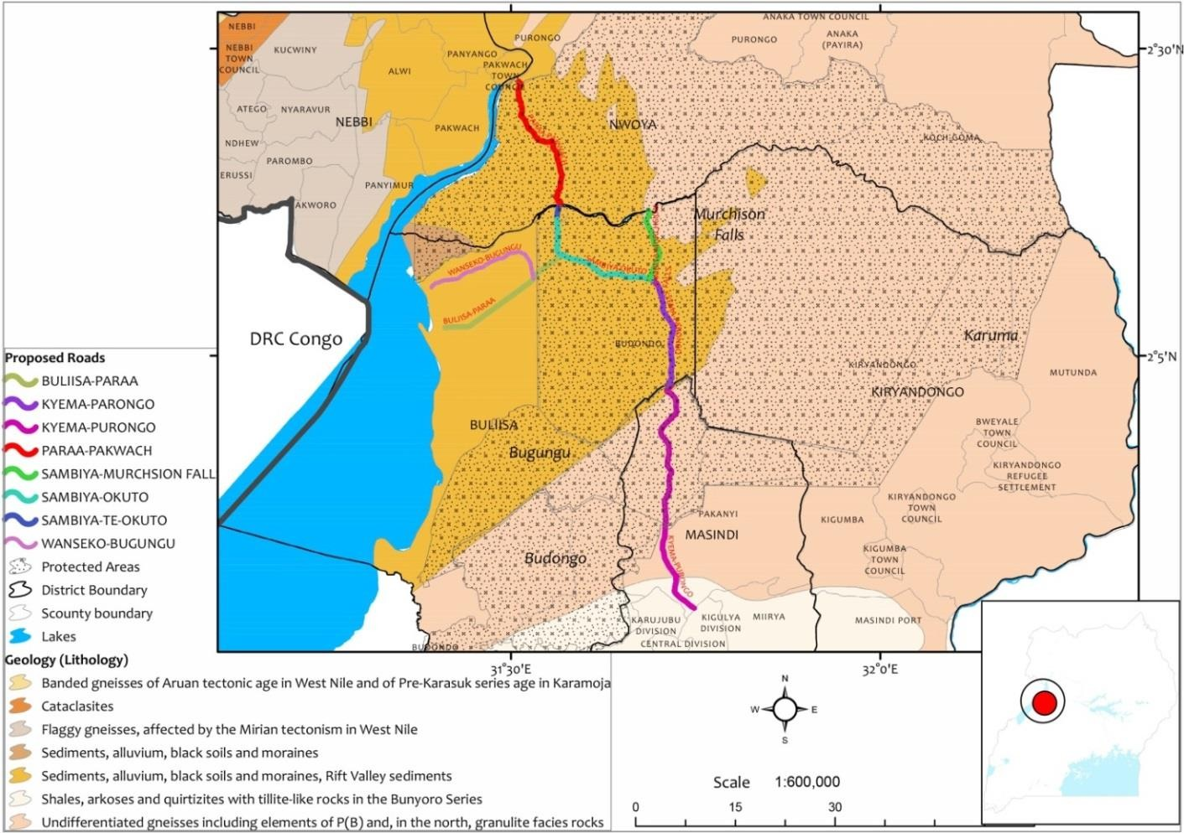
Figure 9: Soils around Murchison Falls National Park (Proposed Chobe and Mupina stream crossings)

Geomorphology and hydrology

Mupina stream
Mupina stream is a permanent in nature with high seasonal variations in one of two tributaries of the greater Mupina River flowing through the Murchison Falls National Park. Downstream of the crossing, the stream is characterized by a highly meandering pattern, with frequent and sharp bends. This is typical of areas where the river's gradient is lower and its flow is slower, allowing the channel to shift laterally across the floodplain. Erosion occurs on the outer curves, while sediment is deposited on the inner curves, shaping the river's path over time. The catchment covers an area of 235.4 km². This is predominantly covered by forests which are composed of trees and shrubs of a height greater than 4m. It also has bushland and thickets with grassland that form pasture animals feed on.

Chobe stream
The Chobe stream is a permanent stream with significant seasonal variations. It flows South East towards the Victoria Nile where it eventually discharges its waters. It is a small stream characterized by dense vegetation growth along its banks which narrows the river channel. It is a slow-flowing river with a wetland 500m downstream of the crossing.

Ecosystems and biodiversity
Murchison Falls National Park lies at the northern end of the Albertine Rift Valley, where the sweeping Bunyoro escarpment tumbles into vast, palm-dotted savanna. Murchison Fall National Park supports a diverse of ecosystems; grasslands, wooded savannah, tropical forests, wetlands, and open water covering approximately 39,000 ha at an altitude of more than 600 m. The park hosts over 76 species of mammals, 10 species of primates, more than 465 species of plants, 250 species of butterflies and 450 species of birds, 450 bird species, and 145 trees. MFNP fresh water supports diverse fish community of over 40 species; 23 species are of conservation concern (IUCN red list); one endemic to the Albertine Rift; and six species introduced to Victoria Nile. Observations during the field visit were made at a radius of 100m and it was noted that the general environment around Mupina River consisted of a savana grassland comprising of pasture dominated by Hyperphenia SSP, Pennisetum purpureum, Brachiria ssp, Penicum maximum, typha ssp, Pavonia urens, Cynodon dactylon among others.
Trees identified around the stream together with their conservation status are indicated in Table 4-1.

Table 4-1: Identified tree species around Mupina stream crossing
Identified tree species | IUCN conservation status
Kigelia Africana | LC
Ficus ovate | Endangered
Vernonia amygdalina | -
Acacia pennata | LC

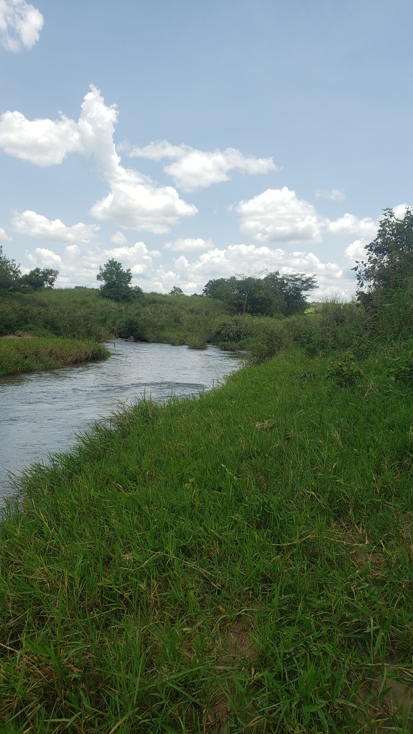
Figure 10: Environmental setting around Mupina stream

Chobe catchment is predominantly covered by forest which is composed of trees and shrubs of a height greater than 4m. It also has bushlands and thickets and some grassland comprising of short grass cover (due to repeated grazing by animals) dominated by Brachiria ssp.
Trees identified around the stream together with their conservation status are indicated in Table 4-2.

Table 4-2: Identified tree species around Chobe stream crossing
Identified tree species | IUCN conservation status
Kigelia Africana | LC
Ficus ovate | Endangered
Acacia pennata | LC
Dracaena steudneri | LC
Senna petersiana | LC
Ficus tinctoria | LC

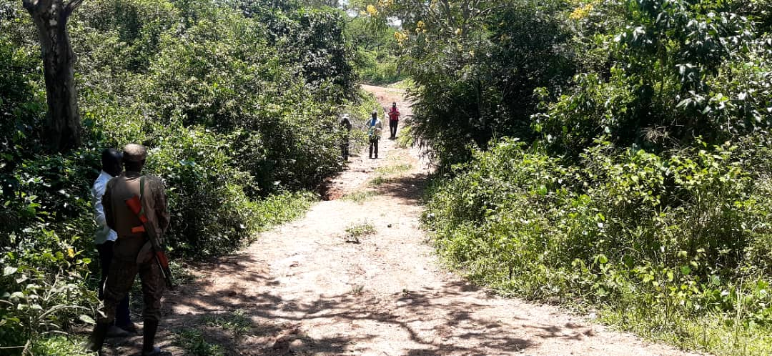
Figure 11: Environmental setting around Chobe stream crossing

Fauna
The rich and varied ecosystems of the MFNP provide habitats for an equally wide diversity of animal communities and species. Wildlife includes lions, leopards, elephants, hyenas, giraffes, hartebeests, oribis, Uganda kobs, baboons, hippos, Nile crocodiles and many bird species. Observations at a radius of 100m were made within the project area and its zone of influence support diversity of large and small species of animals in the aquatic and terrestrial spheres including Antelopes, lions, Waterbucks, Jackson hartebeest, Hippos, buffalo among others.

Avifauna
The MFNP is very rich in bird species whose habitats including savannah forests, grassland, woodland, thicket, wetlands and open water. The thickets and woodlands closer to the riverbank harbor Swallow-tailed and Red-throated Bee-eaters; Woodland birdlife variety include Pied, Giant and Malachite Kingfishers; Francolin; Hornbills, Grey heron; Hamerkop; Shrikes; Flycatchers; Cuckoos; Woodpeckers; Crombecs and Warblers; riverbanks are home to ducks, geese, stilts and plovers; and swamps are well known for wide variety of water birds, including the Shoebill. The bird species of MFNP include Albertine Rift endemics like Northern red bishop, Northern carmine bee-eater, and African fish eagle. No bird nests were observed on plants in the river section at the Mupina and Chobe stream crossing sections.

Aquatic ecology
The terrestrial vegetation in the river channel indicates the rivers have been wet for a considerable time and probably perennial. This trend is anticipated to continue.
MFNP fresh water supports diverse fish community of over 40 species; 23 species are of conservation concern (IUCN red list); one endemic to the Albertine rift; and six species introduced to Victoria Nile.

Mupina and Chobe rivers range from moderate to slow flows at the stream crossing construction sites. Observations made at a radius of 100m indicated that no fingerilngs, neither suitable spawning habitat were registered around the upstream and downstream sections of either rivers.

Air quality
Existing major pollutant sources in the area are scarce, with limited vehicle emissions from UWA and Tourism operations. No observable particulate/ fugitive dust was recorded that necessitate measurement and recording within 2km radius of the project sites due to the rainy season during site assessments.

Noise
No industrial or continuous noise sources were recorded around Mupina and Chobe stream crossings. The average noise levels recorded during field assessment around Chobe and Mupina were 52dB(A) attributed to majorly natural plant movements.

Socio-economic Environment

Location and Administrative structure
Murchison Falls National Park is a famous national park in Uganda, East Africa. It is located in the northern part of the country, within the Masindi and Nwoya District. The park is situated around the Victoria Nile River and is known for its diverse wildlife, beautiful landscapes, and the impressive Murchison Falls. It’s located at coordinates longitude 2.1960° N and Long 31.5860° E at an altitude ranging from 619 meters to 1,292 meters above sea level.

Chobe and Mupina stream crossings are located within Murchison Fall National Park, a protected area under the jurisdiction of UWA. There are UWA outposts within 500m and 1km from Mupina and Chobe stream crossings respectively. These are often utilized by UWA during the monitoring of park operations and the related tourism activities. Chobe stream crossing is located about 20km from the nearest community and Mupina stream crossing is situated about 100km from the nearest community following the existing access roads. This clearly indicates that both sites are deep inside Murchison Falls National Park and there are no households within the immediate project proximity.

Economic activities and sources of livelihood
Tourism is an important generator of foreign exchange, employment and investment. In recent times, there has been increased investment in tourism, particularly in travel, accommodation, and related facilities which has enhanced tourists’ experience in the country. MFNP is currently the most visited national park in Uganda with an average 65,000 annual visitors (UWA, 2019) and tourism is considered as the key economic activity in the vicinity of the proposed project site.

Land tenure and settlement characteristics

The project sites are located within the park which is prohibited from human settlements except for UWA Infrastructures and the tourism concession sites approved by UWA management . Both stream crossings lie outside the community resource access zone as per the General Management Plan for MFNP 2013-2023. Although this General Management Plan has expired, the process of developing a new GMP is on where data collection and analysis has been completed and plan drafting underway. As the process of developing the new plan continues, Management is still carrying forward provisions in the expired GMP which activities were not accomplished within the time period and those that are routine routine in nature such as law enforcement operations, routine maintaince of roads and other infrastructure, deases surveillance, community conservation and human-wildlife conflict resolution, tourism management to mention but a few. These are guied by the purpose and the zoning that were prescribed in the expired management plan until a new plan is approved. These are guied by the purpose and the zoning that were prescribed in the expired management plan until a new plan is approved. The purpose of the expired Management Plan was to “Protect and conserve [Murchison Falls Protection Area] MFPA, one of Uganda’s biodiversity hotspots with varied ecosystems including the wetland of international importance, scenic landscapes, spectacular Murchison Falls, rich cultural and historical sites for the benefit of the people of Uganda and the global community”. The plan identified seven zones within the protected area, each with different management objectives: wilderness, tourism, administrative, critical ecosystems, resource use, active management/recovery and dual management.

Chobe stream crossing lies entirely in the Tourism Zone while Mupina stream crossing lies within the wilderness Zone but in close promixity to the Rabongo Tourism Zone. In both Zones, resource access is not permitted. Land take is also not expected since the area is gazetted and does not allow public settlements.

Stakeholder engagement

Introduction
This chapter presents a synopsis of the views of the relevant stakeholders like UWA Headquarters management, MFNP field rangers, Nwoya and Masindi District Local Governments. The consultation meeting with UWA Headquarters management was conducted at UWA Headquarters located at GPS coordinates latitude 0.336111 and longitude 32.58361, Mubako offices and UWA rangers were consulted on-site as data was being collected and the coordinated are with the site description context. ESS 10 recognizes the importance of open and transparent engagement of project stakeholders as an essential element of good international practice. Recognises effective stakeholder engagement value of improving the environmental and social sustainability of projects, enhancing project acceptance, and making a significant contribution to successful project design and implementation by owning the project.

Objectives of stakeholder engagements
The objectives of the stakeholder engagements were:
• To provide information about the project and its potential impacts to those interested in or affected by the project, and solicit their opinion in this regard;
• To provide opportunities to stakeholders to discuss their opinions and concerns;
• To manage expectations and misconceptions regarding the project; and
• To inform the process of assessing significance of impacts and developing appropriate mitigation measures.

Stakeholder Identification and Engagement
To develop an effective consultation program, it was necessary to determine exactly who the stakeholders were, basing on the definition that a stakeholder is "any individual or group who is potentially affected by a project or can themselves affect a project”. In addition, stakeholder identification and engagement were carried out in line with the ESS10. The identified stakeholders were UWA management including the MFNP staff, tourists, Nwoya and Masindi Local Governments among others.

Stakeholder concerns
Stakeholder consultations were undertaken to disclose the proposed project to the relevant stakeholders and to seek their views about its development and operation. The districts of Nwoya and Masindi are likely to be affected as local people will be considered for employment opportunities. In addition, district representatives were engaged to seek their opinions on the proposed projects. During the stakeholder engagement meeting, the stakeholders raised concerns/issues. Some of the key concerns raised during the various stakeholder engagement meetings are summarized in the table below.

Table 5-1: Views and concerns raised by stakeholders
Area of concern | Remarks/proposed action
Need for the stream crossings | Currently, Chobe stream crossing section floods and cannot withstand heavy UWA vehicles. The proposed new stream crossing should be designed to withstand changes in water volumes.
Need for the stream crossings | Improved stream crossing will interest tourist to visit the area in the park.
Conservation of the park environment | Materials such as murram should be sourced outside the park.
Conservation of the park environment | UWA will verify suggested murram sources for absences of invasive species.
Conservation of the park environment | Take into account environmental aspects associated with the project.
Stakeholder participation and engagement (UWA) | UWA field office should be engaged to participate in all phases of the project
Stakeholder participation and engagement (UWA) | Collaborate with host district during project implementation and monitoring
Safety of the workforce | The project sites are located around areas with large number of animals including lions. In case of any workers camp, these should be properly guarded by UWA rangers during the construction phase to avoid any cases of Human Wildlife Conflict.  To avoid visual intrusions, the contractor(s) should acquire PPE that blends with the park environment to limit disruption of project and tourism activities.
Restoration of disturbed area | Develop and implement restoration plan. Where possible level sites and allow for natural restoration to limit spread of invasive species.
HIV/AIDS Spread control | Create awareness training among workers on the control of spread of HIV AIDS.  Ensure the control of GBVs as a result of income generation from project implementation.
GBV risk mitigation | Contractors and workers will be sensitized about dangers of Gender Based Violance.
Mitigation against Non-inclusion and discrimination | Contractors shall be sensitized about the Bank’s non-inclusion and discrimination policies and ensure they uphold these policies throughout pre-construction and construction phases.
Authorisation of stream crossings construction | Submit stream crossing designs to the district Engineer for review, approval and registration.

Attendance register and Photo of engagement with UWA
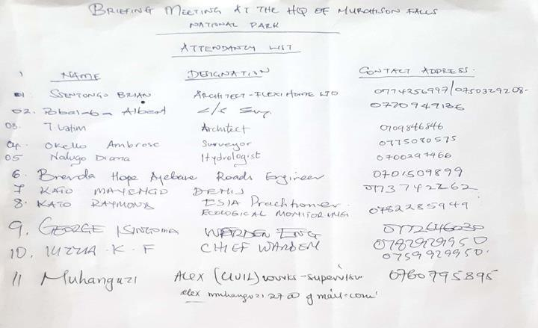
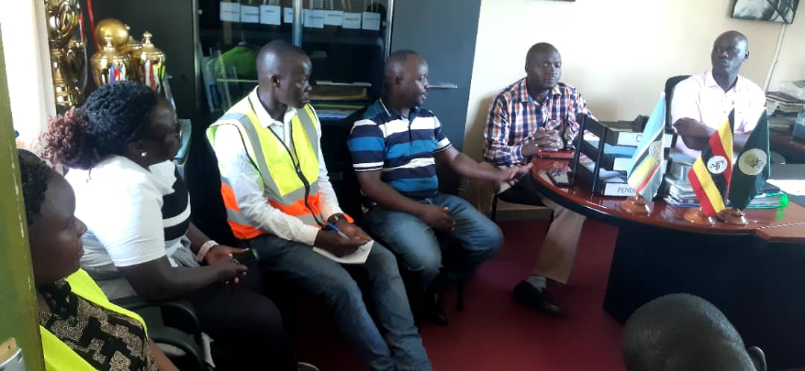
Figure 12: Consultations with MFNP field staff at Mubako head offices

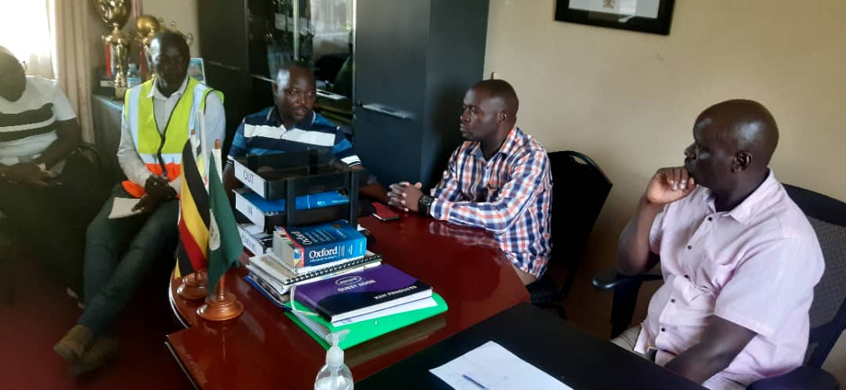
Figure 13: Consultation with the Chief Warden Murchison Falls Conservation Area held at his office in MFNP
Attendance register engagement with Nwoya District Environment Officer
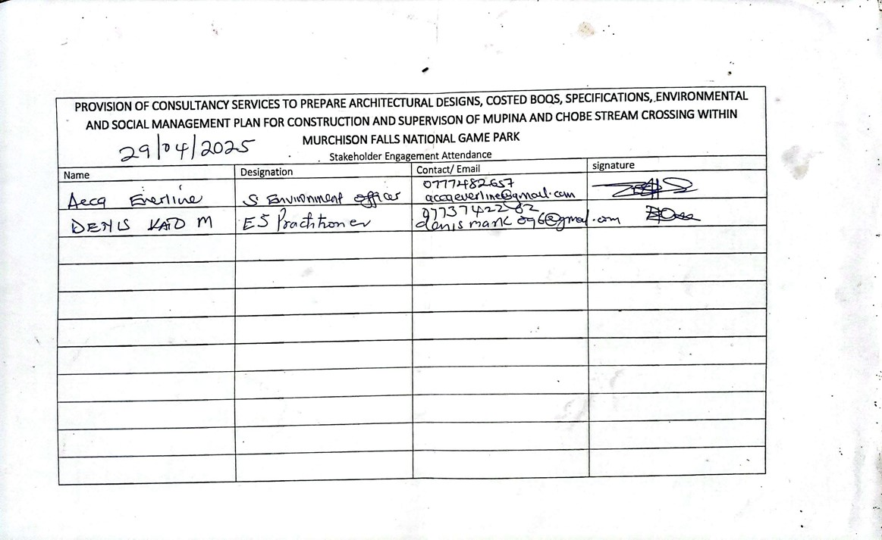

Impact analysis and mitigation
Impact analysis involved determination of nature of impacts, their magnitude, extent and duration to define the level of significance. Potential positive and negative impacts were identified for the pre-construction, construction and operation phases.

Positive Impacts

Preconstruction phase

Market for Construction Materials
Construction materials such as sand, aggregates, gravel and cement shall be required to ensure the facilities are set up. However, gravel and aggregate will be got from outside the national park These will be acquired from the neighbouring trading centres and communities prior to the construction and hence increase income for the business operators around the park.

Negative Impacts

Destruction of Floral characteristics
During site preparation prior to construction, part of the vegetation within the project site's footprint will be cleared. The vegetation to be cleared is mainly composed of low vegetation such as grass and shrubs, as well as invasive plant species. Removal of vegetation cover eliminates essential resources, such as food, nesting sites, and protective cover, impacting the survival and reproductive success of many species. Vegetation loss is a permanent impact but can be compensated through re-vegetation and landscaping. However, considering the scale of the project and type of vegetation found on site and within the project influence area, no significant adverse effects or loss of habitats are anticipated or effect on the ecology of the area.
Mitigation Measures;
- Only vegetation that shall be within the work area shall be cleared and leave out vegetation that is not within the project footprints.
- Selective removal of trees that could be habitat to some species shall be done to ensure minimal habitat distortion. This shall be overseen by the UWA environmental team.
- Selective clearing rather than indiscriminate vegetation removal shall be prioritized by conducting thorough surveys to identify and protect areas of high biodiversity and rare plant species – although none of those were found in the sites surveyed.
- Develop and implement a re-vegetation program to compensate for the lost vegetation but invasive species will be avoided.

Disturbance of Wildlife
The project sites have various animal species including animals of conservation importance such as lions, elephants among others. The noise from machinery and human presence associated with clearing and other construction activities can disrupt normal behavior patterns, breeding activities, and even lead to temporary displacement of these wildlife. Prolonged disturbance and stress can have detrimental effects on the overall health and well-being of the animal population.
Mitigation Measures;
- Sensitization of workers on the dos and don’ts while working in MFNP shall be carried out by UWA rangers before and during the construction phase.
- Earthworks shall be limited to proposed built areas as per the approved site layout plans.
- UWA rangers shall always be with the construction team to ensure construction activities cause minimal disturbances to the wildlife.
- Working hours shall be restricted to daytime and this will ensure less disturbance to the park.
- Water for construction will be obtained from outside the park to minimize disturbances of wildlife that use the water resources within the park.
- Proper storage of food and food waste shall be implemented to prevent the attraction of wild animals to the project sites.
- An emergency preparation plan shall be developed for rangers to handle aspects of animal encounters and attacks.

Risk of introduction of Invasive Species
Invasive species may be introduced through the vehicles that will be delivering construction materials to different sites. These may come on the tyres of vehicles or even through human dispersal. In addition, invasive species may arise due to use of fill materials which may contain these species as well as the type of plants used in revegetation. Given that MFNP already is facing a big challenge of invasive species, this risk should be minimized as much as possible.
Mitigation Measures;
- Vehicles shall be checked and thoroughly cleaned before they enter the protected area.
- All vehicles shall be required to keep on the motorable routes and off-tracking shall be avoided.
- Constant monitoring shall be done to identify any invasive species, and the identified species shall be uprooted and waste valorization, and then use the compost to make bricks and manure maybe considered by UWA.
- For materials such as sand to be obtained from outside the park, sources shall be inspected by MFNP management to ensure there are no invasive species.

Construction Phase
Positive Impacts

Creation of jobs

Much as the proposed stream crossings upgrade project is located in the MFNP, there will be employment of individuals from the neighbouring communities to provide mainly the semi-skilled labour during the project construction phase. Additonally the stream crossings construction will not offer employment to all job seeking individuals, it will nevertheless offer opportunities to the many unskilled local population in need of cash incomes.The beneficiaries shall be involved in surveying work, construction of materialsdelivery/equipment operation, earth material extraction, site mobilization and other related activities.
Enhancement measures
- Available job opportunities shall be disclosed in nearest communities to the construction sites in the park.;
- Contractor(s) shall involve local leaders and the District Local Governments in the recruitment process to ensure full and fair participation of local people; and
- There shall be deliberate ring fencing some jobs for women workers.

Creation of business opportunities
Stream crossings and associated road construction will require some volumes of construction materials including gravel (murram), aggregate (stone), sand among others. Other materials include lime, cement and steel among others. Procurement of these materials will provide income to suppliers and owners of land where quarry sites and borrow areas will be located.
Enhancement measures
- All sites that shall be utilized as material sources including stone quarries shall be those approved prior to supply such materials.
- Earth materials procurement contracts shall be reviewed by competent legal practitioners under the overall supervision of UWA/ District Leadership to avoid taking advantage of landowners where borrow pits and rock quarries are located.
- Contracts shall specifically bind the contract to restoration of completed or abandoned borrow pits and quarry sites.
- All contracts for material source areas shall be witnessed by Local Council chairpersons in consultation with the District Environment and Community Development offices.
- Periodic monitoring shall be specified in the Contractor’s ESMP to ensure environmental and social integrity of material source areas.

Improved park management and tourism
With good road connectivity to different sections of the park previously hindered by the flooding and narrow stream crossing sections, UWA operations and tourism will be improved by stream crossings. These may also include monitoring of illegal activities in the park by established all-round road connection.

Skills Development among local population
Establishment of the project shall require both skilled and unskilled labour to ensure the project is in place. This shall provide opportunity for employment of locals around the park, especially in regard to manual labour, and hence improving their standards of living. Skilled labour shall be provided by the technical and experienced individuals deployed by the contractor(s). Only those skills that are not available within the surrounding areas shall be sourced from other areas to reduce labor influx.
Enhancement measures
- There shall be implementation of the policy on employment of local residents that requires 30% of the work force to be drawn from project districts.
- Individuals especially the youths shall be sensitised on non-monetary benefits accruing to employment from construction project including skills development.
- Employment contracts shall be prepared and signed to guarantee employees progressive placements that facilitate skills development.

Improved Emergency Response
The construction of the stream crossings allows for improved emergency response capabilities within the park. Rangers can promptly respond to incidents such as animal injuries, natural disasters, incidences of human wildlife conflict, or other wildlife-related emergencies. Quick and effective response minimizes the impact on biodiversity and ensures the well-being of wildlife populations. The project's infrastructure supports the conservation efforts by providing a base for immediate action and coordination in critical situations.

Negative Impacts

Sourcing of Construction Materials (murram, gravel and aggregate)
Construction materials like murram will be obtained from operational borrow pits which are being managed by UWA close to the project sites within Murchison Falls National Park. However, there will be negative environmental impacts. The method of their extraction, haulage and state in which sites are left upon project completion all have potential for socio-environmental impacts.

New sites could be associated with the following impacts:
- Stripping of vegetative biomass to create access to material sources,
- Temporary water impoundment during the rainy seasons
- Safety and public health risks of un-restored quarries and borrow pits including breeding of insect vectors, poisonous reptiles and possible drowning of children
- Excessive noise, vibrations and dust from borrow operations and rock blasting at quarries will occur. Noise and vibrations would affect local communities and quarry workers and vibrations will crack structures and affect health of especially elderly people and the sickly.
- Fly rock which damages crops, dwellings/ structures or injure people and livestock,
- Gaping pits due to unrestored pits cause visual blight and scarring of landscapes.
- Haulage impacts, for example, accident risks and road dust could be realized,
- Quarrying of earth materials also has potential to disinter artifacts or other resources of archaeological and cultural significance.
Impact mitigation
- Existing gravel and stone quarries shall be used for as long as they meet the required material specifications and are certified by the National Environment Management Authority to avoid opening new ones.
- Construction works shall be restricted to the approved sites therefore areas outside the approved site shall be avoided.
- Workers and vehicles access will be limited to only the construction areas.
- Contracts shall specifically bind the contractor to restoration of the completed or abandoned borrow pits and quarry sites.
- Landscaping of burrow pits for murrum extraction will be undertaken to minimize soil erosion on the gullies created thereby minimising the risk of accidents for some wildlife species
- All contracts for material source areas shall be witnessed by Local Council chairpersons in consultation with the District Environment and Community Development offices.
- Periodic monitoring will be specified in the Environmental and Social Management and Monitoring Plan as indicated under chapter 7 of this ESMP. This shall be implemented to ensure environmental and social integrity of material source areas.

Introducing non-native species to terrestrial and aquatic environments
Non-native species could be introduced from sourcing of earth materials especially murram from other sources. Some foreign species might be prolific and would compete with and could potentially replace some native species. This will alter and affect the ecosystem integrity.
Impact mitigation
- Equipment will be thoroughly cleaned before they are transported to the project sites.
- Murram sources will be surveyed for presence of invasive species. Only clean sites will be considered for sourcing of earth materials.
- The site will be monitored for sprout of invasive species that will be uprooted and appropriately handled in case of any.

Improper management of cut to spoil
Earthworks associated with site preparation may generate considerable quantities of cut to spoil. Management of cut to spoil can constitute a major disposal challenge when improperly planned. Cut to spoil is often dumped in watercourses where spoil is improperly dumped.

Impact mitigation:
- As a priority, cut to spoil materials shall be spread onraised grounds to avoid interference with the water courses. The Contractor shall prepare and implement a Contractor’s ESMP (C-ESMP) that will form the framework for addressing the negative impacts arising from construction activities. The C-ESMP shall detail key plans intended to mitigate the impacts arising from construction activities, where the waste management Plan shall be one of the key Plans to be implemented by the contractor.

Improper waste management
There is potential for construction waste such as demolition debris, overburden and waste concrete to be dumped in undesignated places e.g. wetlands, causing aesthetic impacts, environmental contamination and health risk. Additionally, dumping waste in watercourses would cause drainage impairment and localised flooding, creating breeding grounds for disease vectors.

Mitigation measures:
- The Contractor will implement a Construction Waste Management Plan (CWMP) for proper waste management.
- Waste collection skips will be acquired and installed for different categories of waste.
- There shall be awareness among workers on proper waste collection.
- There will be a designated area at the construction site and a temporary construction shade shall be put in place for proper collection of waste.
- The contractor(s) shall hire services of waste handler or properly transport the waste from site to designated waste handling site as per UWA guidelines.
- Concrete mixing area shall be drainsed into a sump where cement contaminated water can be contained and reused.

Loss of vegetation and micro-habitat
Construction of the stream crossings will involve clearance of existing vegetation both along the road approach, riparian vegetation as well as work sites that will hold materials. Rehabilitation of other temporary project structures and the associated activities will result in further vegetation clearance. Some vegetation will be permanently lost and surrounding vegetation will experience changes in species composition towards more riparian species. Clearance of vegetation can result into destruction of sensitive/pristine habitats including the wetlands. This can also lead to local habitat fragmentation/isolation. Due to the sensitive location of the project sites within MFNP, the clearing exercise will be strictly controlled and limited to what is absolutely necessary.

Impact Mitigation:
- No construction material shall be sourced from the national park without permission from UWA. These areas would then be rehabilitated as per the Environmental and Social Management and Monitoring Plan as indicated under Chapter 7 of this ESMP. Diligence on the part of the developer and/ or contractors and proper supervision of workforce are important in this respect.
- To maintain the ecological integrity of the project area, it is recommended that only disturbed sites that are susceptible to erosion will be planted with wildlings of the characteristic species from the nearby areas.
- UWA and Contractor will be responsible for maintaining the restoration activities at the susceptible sites including borrow pits and quarry sites until recovery is satisfactory.

Poaching
Presence of construction workers in the park could result in engagement in illegal kills for wild meat. The project sites are rich in wild game which could be hunted down during construction works. The stream crossings once installed could also spur illegal activities especially poaching if ineffective monitoring is provided by UWA.
Impact mitigation:
- All movement of vehicles and equipment in the park away from the construction sites will be subjected to check points and regular inspections .
- Workers will be sensitized on prohibited activities in the park. Codes of conduct with regard to prohibited activities in the park, including other relevant prohibitions such as GBV and sexual harrasmment shall be signed by the workers and regurlarly monitored to ensure compliance
- Road kills will be reported in accordance to UWA procedure and guidelines.
- Construction work will be limited to day time and workers will be maintained in the camp before and after working hours.
- Construction activities and related auxillary facilities shall be monitored and supervised by UWA and other project related regulatory entities.
- Recruitment of local labour shall be scrutinized to avoid people with history of involvement in illegal activities.
- The project and worker’s grievance redress mechanisms shall be disseminated and allow for reporting of suspected poaching.

Air and dust emissions
During the construction of the stream crossings, dust generation within the project site will consequently increase. There are numerous sources of dust generation including the stripping of topsoil, the excavation of soils, ancillary activities such as concrete mixing, and the transport of sand, gravel and finished products (point emissions). Dust will also be generated due to excavation works, movement of construction equipment, fast moving trucks among others. Construction begins with the intense excavation works which gradually reduce once the excavation is done and foundation for construction has been completed. Dust will also be generated throughout the construction phase particularly from operations such as handling cement, delivery of materials, movement of the heavy trucks and equipment’s, among others. A lot of dust will accumulate during development activities. This will pollute the air, impact negatively on wildlife around the sites (project site, material storage area and the yards make water very turbid / brown, and scare fishes and other fauna away in the nearby water bodies.

Impact mitigation
- The contractor(s) shall spray water to reduce dust generation.
- There shall be minimised material load to avoid fall off during transportation
- The contractor(s) shall maintain a speed limit of 40km/hr for vehicles on routes used to access the project site in line with the UWA guidelines.

Noise and vibrations
Construction noise is a major source of environmental noise pollution and a cluster of equipment at these roads under construction can produce a steady roar through the day. Construction of the proposed stream crossings will be associated with generation of considerable noise in the park. Noise will disrupt animal communication making them susceptible to predator and disrupt other natural process such as mating.
The construction works will be carried out during daytime only. The noise during the construction phase depends on the stage of construction work and equipment used at the site. The main sources of noise and vibration during construction of the project are as follows:
- Construction machinery especially during earthworks;
- Haulage and general vehicle movements;
- Batching Plant
- Generators and compressors
Noise can be loud during construction activities. This will affect aquatic organism and other fauna away in the nearby water body and grazing areas. The hand stationary machinery such as generators can also generate considerable noise levels at different parts of the project sites, mostly if under/un-serviced. Vibrations may be caused by the different types of construction equipment, namely; tracked plant, (e.g. dozers and tractor shovels; Rubber-tyred plant (e.g. motorized scrappers and dump tracks); continuous or intermittent impacting plant (e.g. pile drivers and vibratory rollers).

Impact mitigation
- Construction works will be limited to day time.
- Machinery in good working condition shall be utilised during construction and shall be duly serviced.
- Idling of construction equipment shall be discouraged.
- There will be installation of less noisy movement/reversing warning systems for equipment and vehicles that will operate for extended periods, during sensitive times or in close proximity to sensitive sites.
- All vehicular movements to and from the site will occur during the scheduled normal working hours, unless approval has been granted by the Site Engineer.
- All trucks that shall be used to transport construction materials shall be kept in good conditions so that they do not produce excessive noise and ensure control of the truck speed that is not to exceed 40 km/hr when driving within the park and the contractor shall be required to ensure the same speed limit of 40km/hr is maintained through communities.
- Provision of noise protection kits such as ear plug, earmuff, for workers in the area with noise level is higher than 85 dB(A).

Disturbance and Habitat Alteration
The construction of the stream crossings will involve noise and vibration that may cause short term (lasting during the construction time) disturbance to fauna that occupy adjacent habitats. The primary causes of noise and vibration may come from traffic and equipment operation and movement, clearing and excavation, rock breaking and construction.

Disturbance of wildlife communities from the increased activity resulting from the stream crossings construction may be in form of noise or increased access by people and can be a significant form of stress upon the populations particularly if they are sensitive species.

Mitigation Measures
- Existing roads shall be utilized to access sites;
- Monitoring of vibration and noise shall be carried out at construction sites and access roads in order to assess the effectiveness of noise and vibration mitigation measures.

Generation of waste water
Activities involved in the construction of the stream crossings may generate reasonable quantities of waste water. The most significant wastewater quantities may be generated from on-site cleaning of machinery. These waste water quantities, when improperly stored or disposed of, may lead to unsanitary conditions resulting into pollution of the environment and run off.

Impact mitigation
- Wastewater generated from the mobile toilets shall be transported and managed outside the protected area.
- Construction workers shall be inducted to utilize available convenience facilities.
- Machinery cleaning shall be undertaken at designated location for easy management of the generated wastewater.

Impacts on Water quality
During construction, impacts of soil erosion and deposition of sediments will occur hence affecting the quality of the rivers in the following ways.

- Siltation (deposit of soil and sediments) of the river
Construction activities like excavation, compacting, clearance of vegetation, installation/repair of culverts, cut and fill, will loosen soils that may be eroded by storm water into the river water near the stream crossings, causing siltation. Indeed, it's clear that soil erosion and sediment re-suspension can result from excavation and construction operations.
Increase in sediment load in watercourses would temporarily impair water quality but impact magnitude depending on size (flow of river), construction methodology and preventive strategies instituted. There may also be short-term effects downstream during construction as a result of mobilisation of sediments around construction activity caused by soil disturbance and erosion and scour of the riverbed at the outlet of the diversion.

Soil from stock piles of top soil and spoil material at quarry sites or borrow pit areas and construction sites may be eroded into existing drainage channels redirecting water to streams within the vicinity, any streams and other water sources that may be within the vicinity of such sites.

Impact Mitigation
- Designs of the stream crossings shall provide for prevention of scouring using gabions, stone pitching or lining banks with concrete and their location shall be such as not to cause increase in sediment concentration or significant changes in flow velocities.
- Stream crossing construction shall utilise sediment control measures such as damimg.

Increase in turbidity of water sources
Siltation of the rivers as a result of loosened soil, dust and other project spoil materials being eroded into them by storm water and/or wind will increase the turbidity of the water in the project area streams and hence degrade the quality of the water therein.

Impacts associated with storage of construction materials including petroleum products
Stock piling construction materials near work sites is a normal practice during construction. Contractors stockpile and store assorted materials at or near construction sites to ensure uninterrupted access to supplies. This could lead to pollution of land and of watercourses by spilling and wash away of materials. This impact may occur around the stream crossings to be constructed and receptors are soil and water resources near storage sites dependent on affected environmental resources. This will be short-term impact only occurring during the construction period and local in extent. However, spills in watercourses can impact remote/ distant downstream ecosystems and communities.

During the implementation of project activities, poor waste management and oil and fuel leaks will contaminate the soil, surface and ground water thus affecting its quality.

Potential contaminants during the construction include: packaging (paper, plastics, wood); plastic liners; food; oil spillages, worn out personal protective and oily rugs. If not properly managed, this waste has the potential to contaminate soil at or within the vicinity of the project area.

Impact mitigation
- Stockpiles shall observe legal provisions regarding distances from water sources and wetlands.
- Contractor(s) shall protect material stockpiles from storm water erosion (e.g. by excavating a cut-off ditch around stockpiles to keep away storm water).
- Contractor (s)shall provide impermeable lined and bunded storage for fuel.
- All fuel storage sites shall be drained through oil skimming sumps.
- Contractor(s) shall cover material stockpiles containing fines with fabric or other materials.
- The project contractor(s) will ensure that all wastes generated during construction activities are collected and disposed of appropriately at designated sites;
- All organic waste generated at the project site such as food waste shall be collected and transported to designated landfills/dumping sites outside the protected area;
- All plastic waste generated in the course of undertaking works such as mineral water bottles, polythene bags, jerry cans, will be collected in waste bins/ mobile vans and handed over to a licensed waste collector or re-used;
- All wastes emanating from the refuelling procedures and contaminated soils will be treated and handled in accordance to the hazardous waste management procedure;
- There shall be monitoring of the water quality and devise corrective action when changes attributed to project implementation have been observed;
- Contractor(s) shall ensure routine preventive maintenance of motorised equipment to avoid any fuel leakage and spills; and
- All waste generated from project activities will be collected and disposed of in accordance with the local district guidelines, National Environment (Waste Management) Regulations 2020.

Occupational health and safety
Construction activities such as excavation and concreting can pose occupational hazards and risks to construction workers. They can cause respiratory infections and injuries to limbs and body due to exposure to dust and combustion gases, operation of equipment and handling of construction materials. Accidents may occur during construction due to workers falling from heights or being hit by falling construction materials or tools. Dust and combustion gases can irritate the eyes causing trachoma and respiratory problems. The operation of construction equipment and handling of materials can result in injuries to the workers, especially in the absence of appropriate personal protective equipments. The health of the site workers may be further compromised by the food which is often supplied by mobile individuals with no licenses to handle food and some of the foodstuffs may be prepared in unhygienic manner.There are safety risks associated with working at construction sites with various types of materials and machines, equipment, and with many vehicles involved in the transportation of the construction material from the storage area to the construction site. .

Impact Mitigation
- Depending on the occupational safety and health hazards encountered while performing assigned tasks, workers will require using properly fitting personal protective equipment (PPE) to avoid injuries and illness. They (workers) will be provided with full protective gear. These include working/safety boots, overalls, helmets, goggles, earmuffs, masks, gloves etc. All equipment will be inspected before use for appropriate safeguards.
- Controlled working hours will be provided and employees will not extend working hours unnecessarily.
- The contractor(s) will adopt effective emergency response plans. A good start to learning how to respond to an emergency is through certification in Basic First Aid, mostly for snake and insect bites. Regular drills and emergency situations will be followed to impart the anticipated insight and awareness to the workers.
- A first aid kit will be provided within the site. This shall be fully equipped always and shall be managed by qualified persons.
- Safety awareness shall be gained through regular safety training or personal interest in safety and health.
- Strict adherence to safety measures and procedures will minimize (or eliminate) risks of accidents or hazardous developments occurring.
- Construction equipment will only be operated by qualified personnels.
- Workers on site shall be guarded by the rangers provided by UWA to control any human wildlife conflicts.
- Site inductions and trainings will be conducted for all workers and visitors.
- Scaffolds Guard rails will be installed on either side of the stream crossings to guide operators onsite.
- Workforce shall access the basic first aid and health support onsite.
- All unsafe working conditions shall be report through the Grievance Redress Mechanism as indicated under section 7.6.1 of this ESMP.

Risk of fire outbreak
Stream crossings construction will be associated with a number of auxiliary components that are very prone to fire outbreaks. For instance, the meal preparation and equipment yard activities to be undertaken on the proposed project area such as fuelling stations, workshop among others. An establishment of this size and nature could easily be gated by fire due to presence of heat and petroleum products. Fire can cause minor injuries, fatal injuries and can destroy property worth millions of dollars. If not contained fire could go wild causing habitat loss and affecting ecosystem integrity. The possibility of fire might be intensified by the nature of materials and machinery at site. Fire holds potential to destroy property and can be caused by several acts/situations including smoking indoors, electrical faults, among others.

Impact mitigation
- Fire prone behavior such as smoking will be strictly prohibited onsite.
- Adequate fire-fighting capacity will be availed to fend off large fires. Fire extinguishers will be provided in easily accessible areas throughout the project site.
- Regular training will be conducted on fire prevention and fire-fighting.
- No smoking signage will be displayed on site at potential fire prone areas.
- Open burning of waste as a means of disposal will be prohibited.
- All combustible materials shall be properly stored and these will be regularly inspected.
- UWA will coordinate with any local fire service for rapid response.
- Due to the sensitivity of the project sites, the contractor (s) shall coordinate with UWA management and ensure that there is a local service provider to respond rapidly to any on site fire outbreak.

Increase of HIV/AIDs and STDs
The proposed construction works will attract 25 workers at each site both the skilled and non-skilled. These workers could be migratory, largely male and of young age. Their continuous movement from place to place keeps them away from their wives and families rendering them susceptible to several relationship and intimacy (sex), which normally exposes them to the risk of HIV/AIDS or other sexually transmitted diseases (STDs). Though the workers are at the greatest risk, the people in the community are also at a risk due to possible sexual relations with the migrant workers. Though the impact is temporal (exists only as long as the construction is taking place), the consequences of contracing a disease like HIV/AIDS may be irreversible.

Impact mitigation
- Workers shall be regularly sensitized on the spread of infectious diseases such as HIV/AIDS
- There shall be regular provision of adequate prevention measures such as condoms.
- Workers shall be encouraged to go for HIV voluntary counseling, testing and referral services;
- Workers and the community shall be sensitized on protective behaviour and practices during work by distributing appropriate education materials to workers and the surrounding community. This shall be mainly implemented in the communities where the project workers camp will be established during the contruction phase.
- Contractor(s) shall ensure that sexual harassment is prohibited in the codes of conduct signed by every project worker.
- Local labor shall be prioritized to reduce the scale of labor influx within the camping community.
- A confidential Grievance Redress Mechanism channel to report and address HIV concerns shall be sensitized to all workers.
- The Contractor(s) shall provide surveillance and active screening and treatment of workers and the community where a communicable disease is discovered.

Violence against Children (VAC)
Violence against Children (VAC) is also very common case in Uganda. In the 2018, Violence against Children Survey conducted by MGLSD reported that the most common cases of VAC included sexual abuse and exploitation child sacrifice, child labor, child marriage, child trafficking among others (no district data is available so national data was used). It is, therefore, very possible that a construction project may attract underaged workers seeking employment and opportunities to earn a living.
Impact mitigation
- There will be adequate sensitization for the contractor (s)not to recruit children.
- Contractor(s) will keep record of the age numbers for all their employees so as to avoid employing those below the age of 18; and verification documents such as copies of National IDs shall be kept on site.
- Contractor(s) will ensure that no cases of VAC will be tolerated on the project sites. Verification of the ages of everyone being employed will be undertaken to ensure that nobody below the age of 18 years is hired on the project.

Climate Change Impacts
The construction and operation activities of this project may lead to deforestation and habitat loss, reducing the park's carbon sequestration capacity and disrupting local ecosystems. Additionally, increased greenhouse gas emissions from construction activities and ongoing energy use could further contribute to climate change. Furthermore, the park's ability to provide critical ecosystem services, such as carbon storage and flood regulation, could be compromised although this is unlikely due to the footprint the project is expected to cover.

Mitigation measures
- Strict biosecurity protocols shall be enforced, including the cleaning of construction equipment and vehicles before entering the site.
- Climate resilient materials and designs that can withstand extreme weather events, such as heavy rains, which may occur during or after construction shall be included in the project designs.
- Eco-friendly building materials and energy-efficient designs shall be implemented and these shall can significantly reduce habitat loss and greenhouse gas emissions.

Post construction Phase
Positive Impacts

Improved road network
Improvement of the road will have positive, significant and long-term local, national and regional socio- economic benefits below as highlighted below;

- Improved UWA park monitoring and maintenance operations.
- Reduced vehicle wear/ tear.
- Support to tourism in terms of improved accessibility to the different tourism sites.
- Reduced travel time.

Impact enhancement:
- Stream crossings and associated design shall provide facilities (minor humps) and signage to protect users across the project sites,
- The project designs shall include proper drainage with stream crossing /shoulder protection.
Negative Impacts

Improper drainage of stormwater from the road
There will be the risk of surface runoff from the road/ carriageway and discharged into stream. This might result in siltation of the river overtime. It should however be noted that the stream crossing designs are made to solve existing culvert breakage with the hope that the approved design will provide a permanent solution.

Impact mitigation
- Associated road design shall provide for erosion protection works at outfall drains.
- There shall be erosion protection measures e.g., scour checks, lining of drains. Additionally, regular drains maintenance will also minimise soil erosion.
- Construction of interception ditches, settling ponds shall prevent muddy water ingress into surface watercourses.

Accidents involving wildlife
Wildlife could be at risk of road kills if warning signs and speed control humps are either not provided or not observed by motorists at particular locations. Wildlife could be accidently knocked down by UWA and tourism vehicles during both UWA operations and tourism activities respectively. Road kill would be a negative and chronic impact on wildlife and tourists encountering incidents along the truck.

Impact mitigation
- The plausible control will be ensuring speed control at critical locations of primate’s habitats safety signs and speed humps.
- Motorists (UWA staff and tourists) will be expcted to report any accidents involving wildlife to UWA management.

    - Increased Poaching
Even though the constructing of the stream crossing is intended to improve tourism accessibility, there may proliferate illegal activities especially poaching due to faster movement.

Impact mitigation

- UWA shall monitor activities of motorists including tourists.
- UWA shall undertake routine monitoring of the park including the status of stream crossings for sustainability.

ENVIRONMENTAL AND SOCIAL MANAGEMENT AND MONITORING PLAN

Introduction:
Environmental and Social Management and Monitoring Plan (ESMMP) involves the implementation of mitigation measures to eliminate or reduce significant adverse environmental and social-economic impacts of a project to acceptable levels. Environmental monitoring is a long-term process, which should begin at the start of construction and should continue throughout the life of the project. Monitoring establishes benchmarks so that the nature and magnitude of anticipated environmental and social impacts can be continually assessed. The overall objective of environmental and socio-economic monitoring is to ensure that recommended mitigation measures are actually implemented during the construction and operation of both Mupina and Chobe stream crossings.

Key stakeholders in the implementation and monitoring of the ESMMP activities are: The Contractor(s), The proponent (Uganda Wildlife Authority), Nwoya and Masindi District Local Governments, and regulatory authories such as NEMA.It is recommended that, during the project implementation, there must be coordination amongst the relevant stakeholders regarding the environmental and social issues.

Environment and Social Management Plan (ESMP)
The goal of the ESMP is to ensure that environmental and socio-economic issues continue to be fully integrated into the decisions of the developer while promoting resource allocation efficiency throughout the lifetime of the project. It provides a framework for managing and monitoring impacts for the life of the project. It is designed to ensure that the commitments/mitigation measures in this ESMP, and in any subsequent assessment reports, together with any license approval or similar conditions, are implemented. This ESMP has been designed as a summary of proposed mitigation measures, monitoring, and institutional measures to be taken during implementation and operation to eliminate or reduce adverse environmental and social impacts to acceptable levels as per provisions within the National Environment Act Cap.181. The time frame for implementation of these mitigation measures and monitoring is also specified. The UWA Team shall conduct monitoring, record-keeping and reporting, so as to ensure the contractor(s) keeps in line with the environment regulations. The Contractor(s) will prepare their own Contractors’ ESMP (C-ESMP) and report on its implementation monthly to UWA and other relevant stakeholders. For each impact or operation which could otherwise give rise to impact, the following information is presented:

- A comprehensive listing of the mitigation measures (actions) that each of the identified stakeholders shall implement,
- The parameters that shall be monitored to ensure effective implementation of the action,
- The timeframe for implementation of the actions to ensure that the objectives of the mitigation are fully met, and
- The responsible person/party to implement the measures.

Roles and Responsibilities for ESMP Implementation
This section details institutional responsibilities for environmental and social management and monitoring. The overall responsibilities of coordination of the projects lie in UWA as the executing agency for the proposed construction and rehabilitation of Chobe and Mupina stream crossings under the IFPA-CD project. UWA working in close collaboration with technical teams from the Nwoya and Masindi District Local Governments such as Environmental officers, Engineers etc. will ensure compliance with environmental laws, policies and regulations. Technical experts well-trained and qualified with the capacity to implement the Environmental and Social Management Plan (ESMP) will be identified and recruited. Oversight responsibilities will be undertaken by the Project Technical Committee from UWA.

ESMP Implementation Arrangement

This implementation arrangement during the different project phases requires the involvement of several stakeholders and agencies, each with different roles and responsibilities including UWA, the Contractor(s), the Construction Supervision Consultant (CSC), among others. To ensure effective implementation of the ESMP, the following structure shall be used to ensure the project is executed in line with the contractual expectations. In order to ensure compliance with the ESMP, at least one technical stakeholder from the identified institutions will be appointed. The mentioned stakeholders must ensure that the above-mentioned and required staff to be designated for the joint oversight for the project, are adequately qualified and that the necessary resources are provided and maintained throughout the project's life cycle.

Responsibilities of Stakeholders in Monitoring Project Compliance
According to the IFPA-CD project Environmental and Social Management Framework, the environmental and social safeguards monitoring will be carried out by UWA, and other regulatory entities (the latter, working closely with District Local Governments to carry and ensure effective monitoring of environmental and social risks. Monitoring of environmental and social standards will also cover all project activities. The roles and responsibilities of the key parties and their relationships regarding the implementation of the ESMP in both the construction and operation phases are described as follows:

Entity | Responsibilities
UWA | UWA will be responsible for monitoring the overall project implementation, including environmental and social compliance of the construction of both Mupina and Chobe stream crossings. UWA will be responsible for ESMP implementation and environmental and social performance of the proposed project during the construction and operational phases. Specifically, UWA will:  - Closely coordinate with local authorities in the participation of the community during project preparation and implementation;  - Ensure adequate Enironmental and Social Health and Safety terms and conditions are included in all bid documents and subsequent contracts  - Monitor and supervise ESMP implementation including incorporation of ESMP into the detailed technical designs, bidding and contractual documents, and during the project's operation phase.  - Ensure construction contractor(s) obtain all necessary EHS permits and authorizations  - Ensure that an environmental management system is set up and functions properly; and  - Oversee reporting on ESMP implementation and Environmental and Social incident reporting to the World Bank. In order to be effective in the implementation process, UWA will assign Environmental and Social Staff(s) (ES) to help with the environmental and social aspects of the project
UWA Environmental and Social Staff(s) | The Environmental and Social staff will be responsible for monitoring the implementation of both Mupina and Chobe stream crossing ESMP. Specifically, the officer(s) will be responsible for:  - helping UWA incorporate ESMP and other ESHS terms and conditions into the detailed technical designs and civil works bidding and contractual documents;  - helping UWA incorporate responsibilities for ESMP and other ESHS terms and conditions and supervision into the TORs, bidding and contractual documents for the Construction Supervision Consultant (CSC);  - providing relevant inputs to the consultant selection process;  - reviewing reports submitted by the CSC;  - conducting periodic site checks; and  - preparing environmental and social performance section on the progress, environmental and social incident reports and review reports to be submitted to the responsible authorities and the Bank.
Construction Supervision Consultant (CSC) | - The CSC will assign Environmental and Social Staff(s) and will be responsible for routine supervision and monitoring of all construction activities and for ensuring that Contractors comply with the requirements of the contracts.  - The CSC will engage sufficient number of qualified staff members (e.g., Environmental Engineers) with adequate knowledge on environmental protection and construction project management to perform the required duties and to supervise the Contractor’s performance.  - The CSC will also assist the Local governments in reporting and maintaining close coordination with the local community.
Contractor | - The contractor will assign Environmental and Social Staff(s) to carry out Environmental and Social mitigation measures proposed in ESMP. Based on the approved environmental specifications in the bidding and contractual documents, the Contractor is responsible for establishing a Contractor ESMP (CESMP) for each construction site area, submit the plan to UWA and CSC for review and approval before commencement of construction and report monthly on CESMP implementation. In addition, it is required that the Contractor get all permissions for construction (traffic control and diversion, excavation, labor safety, etc. before civil works) following current regulations.  - The Contractor is required to appoint a competent individual as the contractor’s on-site Safety and Environment Officer (SEO) who will be responsible for monitoring the contractor‘s compliance with health and safety requirements, the CESMP requirements, and the environmental and social specifications .  - Take actions to mitigate all potential negative impacts in line with the objective described in the C-ESMP and promote actions that enhance positive impacts.  - Ensure that all staff members and workers understand the procedure and their tasks in the environmental and social management program.
Local government | - Oversee implementation of project under recommendations of UWA to ensure compliance of project related legal requirements and regulations.  - District Environmental Officers through NEMA are responsible for monitoring the compliance with the national environmental requirements and standards.
UWA Rangers | - The Rangers have the right and responsibility to routinely monitor environmental performance during construction to ensure that their rights and safety are adequately protected and that the mitigation measures are effectively implemented by contractor(s).  - The UWA rangers will provide security to the project workers and ensure that there are no human wildlife conflict within the project sites mainly during the construction phase.

Table 7-1: Environmental and Social Management and Monitoring Plan for Mupina and Chobe stream crossings construction
Environmental/ social impact | Proposed mitigation and Enhancement measures | Monitoring Indicators | Capacity building required | Recommended Frequency of Monitoring | Responsible Actors | Estimated costs (UGX)
Positive Impacts
Enhanced Wildlife Protection | UWA to provide monitoring and supervision equipment to rangers such as smartphones, cameras and GPS machines. | - Reduced poaching rate | Training on use of monitoring equipment | Monthly | UWA Rangers | 10,000,000
Improved Emergency Response | Avail emergency response kits to rangers, specific to their work area. | - Reduced the number of losses during an emergency.  - Improvement in emergency handling procedures | Training in emergency preparedness, response and management. | Quarterly | UWA Rangers | 5,000,000
Employment opportunities | - Timely payment.  - Having formal contracts for the workers.  - The contractor should involve local leaders in the recruitment process to ensure full and fair participation of local communities and screening out of lawbreakers.  - To the extent possible, equal employment opportunities shall be available for women during construction. | - Employment records of workers in adherence to the law  - 41% of contractor workers. sourced from the local communities | Hire of skilled and unskilled labour. | Monthly reports | Contractor, UWA, Masindi and Nwoya District Local Government. | Contractual sum
Negative Impacts
Construction Phase Impacts
Destruction of Floral characteristics | - Clear only vegetation that shall be within the work area and leave out vegetation that shall not affect the establishment of the campsite components.  - Develop and implement a re-vegetation program to compensate for the lost vegetation but invasive species will be avoided | - Minimal clearance of vegetation and soil stripping  - Restoration plans in place  - Neighboring vegetation kept intact | Sensitization | Monthly during the construction | Contractors, CSC | Contractual sum
Wildlife Disturbance | - Sensitization of workers on the dos and don’ts while working in MFNP shall be carried out by UWA rangers before and during the construction phase.  - UWA rangers shall be provided to move and be with construction team at all times to ensure construction activities cause minimal disturbances to the wildlife.  - An emergency response plan shall be developed for rangers to handle aspects of animal encounters and attacks. | - Restoration plans in place  - Neighboring vegetation kept intact.  - Proper food waste storage on site.  - Presence of an emergency response plan. | Sensitization and Public awareness campaigns  Proper food storage and handling | Monthly during construction | Contractors, CSC | 10,000,000
Risk of Introduction of Invasive Species | - Inspection of vehicles shall be done and where necessary equipment and vehicles shall be cleaned to prevent the unintentional spread of invasive species.  - Sources of construction materials such as murram, aggregates and sand shall be inspected to ensure they are free from invasive species. | - Absence of invasive species around the construction areas.  - Record of invasive species that are cleared around the site. | Sensitization of contractor’s workers. | Quarterly | Contractors  UWA rangers | 10,000,0000
Noise and vibrations generations | - Routine noise and vibration level assessment will be undertaken to ensure that the noise levels are kept within the recommended standards  - Where possible construction equipment will be fitted with silencers to reduce the noise generated;  - Construction activities shall be carried out only during the day  - Construction vehicle drivers and machine operators shall be sensitized to adopt a habit of switching off the engines of their vehicles or machinery when they are not in use.  - Hooting will be prohibited within the park. | Construction equipment noise emissions within acceptable limits. | Education and control through enforcement  Sensitization campaigns | Bi-weekly | Contractors, CSC, | 10,000,000
Waste Management | - Waste segregation at source into different waste categories before disposal shall be encouraged.  - A licensed waste management firm for the disposal of large quantities of solid waste shall be contracted.  - All reusable materials will be reused to minimize the quantity of solid waste generated.  - All the solid waste will be collected by NEMA-licensed waste collectors and disposed of in a certified facility. | - Dumpsites available in place.  - Site cleanliness  - Number of waste/debris on site  - Disposal methods of solid waste from the site  - Records for hazardous waste | Sensitization and awareness activities.  Environment sensitization programs | Daily,  weekly and  monthly | Contractors,  CSC, UWA | 10,000,000
Gender Based Violence | - Sensitization of construction works shall be undertaken and included in the construction contract conducted throughout the projects.  - Any form of GBV will be referred to the police for handling. and where necessary psycho-social support shall be provided by the GBV service provider;  - Workers will be required to sign a code of conduct as per the standard World Bank contract template and the Labour Management Procedures developed for the project; | - Record of sensitizations on GBV aspects.  - Police cases on GBV related to project workers  - Cases handled by GBV service provider. | Sensitization | Monthly | Contractors,  CSC, Masindi and Nwoya District Local Governments | 10,000,000
Occupational health and safety | - Depending on the occupational safety and health hazards encountered while performing assigned tasks, workers may require using properly fitting personal protective equipment (PPE) to avoid injuries and illness. They (workers) will be provided with full protective gear. These include working/safety boots, overalls, helmets, goggles, earmuffs, masks, gloves etc.  - A first aid kit will be provided within the site. This should be fully equipped always and should be managed by qualified persons.  - Safety awareness may be gained through regular safety training or personal interest in safety and health.  - The Contractor will be having workmen’s compensation cover. It should comply with the Workmen’s Compensation Act, as well as other Ordinances, Regulations and Union Agreements.  - Workers will always be sensitized to social issues such as drugs, alcohol, diseases etc. | - Record of PPEs distributed to workers on site.  - Fire prevention equipment in place.  - PPE used on-site by workers.  - First Aid kits are available on construction sites.  - Sanitation facilities cleanliness. | Awareness and education  First Aid management | Monthly | Contractors,  CSC | Contractual sum
Violence Against Children | - Adequate sensitization for contractors not to recruit children.  - The contractor will keep a record of the age numbers of all their employees so as to avoid employing those below the age of 18 and verification documents such as copies of national identification will be kept on site.  - No cases of VAC will be tolerated on the infrastructure projects, and these will be punishable by law. | - Employment record details.  - Human resource manual in place.  - No police cases regarding children on the project. | Awareness activities and education | Quarterly | Contractors,  CSC
 |  |  |  |  |  | 10,000,000
Post Construction Phase
Poor waste management | - Sensitization of rangers on proper waste management practices shall be done to ensure proper implementation of waste management strategies during the operational phase.  - All waste collected shall be disposed of outside the protected area in an environmentally sound manner by certified waste handlers.  - Sanitary facilities should be routinely cleaned to minimize risks of diseases | - No littered waste around the stream crossings | awareness and education on  waste management | Daily | UWA Staff | 10,000,000
Human Wildlife Conflict | - Properly store food waste in enclosed collection bins.  - Sensitize rangers to avoid feeding wild animals and always to ensure to keep a safe distance.  - Carry out continuous training by rangers on the management of different wildlife in case of unfriendly encounters. | - Presence of appropriate food storage containers.  - Number of incidents on unfriendly wildlife encounters.  - Number of sensitization sessions. | Sensitization on animal handling and proper waste management. | Daily  Quarterly | UWA Staff | 10,000,000
Natural Disaster Related Risks | - Develop and regularly update comprehensive emergency preparedness plans to cater for natural disasters.  - Conduct drills and training sessions to ensure all personnel are familiar with emergency procedures. | - Presence of an emergency response plan that includes natural disasters.  - Record of drills on emergency response. | Provide professional support during emergency drills. | Bi Annually | UWA Staff | 10,000,000

Grievance Redress Mechanism

Overview
UWA has a grievance handling mechanism used to manage community grievances that occur in projects they implement. This grievance handling system shall be applicable for the project to ensure it is executed appropriately. In addition,the WorldBank’s ESS2 requires that all contractors on a funded project shall establish a grievance mechanism for all direct workers and contracted workers to ensure that workers’ concerns at the workplace are raised. The contractor will need such a mechanism immediately after contract signing and prior to mobilization on site. Furthermore, the grievances related to workers and those related to the communities will be addressed in line will the general grievance management plan that was prepared during the project formulation. The service provider for GBV aspects shall be vetted by UWA to ensure they are qualified to carry out the required activities.
This mechanism, therefore, describes avenues for project affected stakeholders to raise complaints or grievances against the project, its staff or contractors during its implementation. It also describes the procedures, roles and responsibilities for addressing grievances and resolving disputes.
The construction and rehabilitation of both Chobe and Mupina stream crossings will therefore follow UWA’s Grievance Redress Mechanism.

Grievance Redress Process

Step 1: Receipt of complaint
A verbal or written complaint from a complainant will be received by the site supervising engineer or foreman and recorded in a complaints log kept on site. The complainant will be provided with an acknowledgement receipt of the complaint in less than 24hrs this complaint will then be sent to the committee in the same day received or latest within 24h for assessing a grievance. Additionally to ensure confidentiality of the complaints, there will be phone contacts and emails shared with the project related stakeholders for easy communication.

Step2: Assess the Grievance
During the assessment, the team gathers information about the case and key issues and concerns and helps determine whether and how the complaint might be resolved.

Step 3: Determination of corrective action
If in his/her view, a grievance can be solved at this stage, the site supervising engineer will determine a corrective action in consultation with the aggrieved person or community. Grievance resolution can be achieved following the approaches listed below:-
- The project proposes a solution.
- The community and project personnel’s (sociologist) decide together.
- The project and community defer to a third party to decide.
- The project and community utilize traditional or customary practices.
All corrective actions will be handled in line with UWA’s already exisiting Grievance Redress Mechanism.

Step 4: Meeting with the complainant
The proposed corrective action and timeframe in which it is to be implemented will be discussed with the complainant within 5 working days of receipt of the grievance. Consent to proceed with corrective action will be sought from the complainant and witnessed by the area’s local council chairperson

Step 5: Implementation of corrective action
Agreed corrective action will be undertaken by the project or its contractor within the agreed timeframe. The date of the completed action will be recorded in the grievance log.

Step 6: Verification of corrective action
To verify satisfaction, the aggrieved person will be asked to return and resume the grievance process, if not satisfied with the corrective action.

Step 7: Action by Grievance Committee
If the complainant remains dissatisfied and a satisfactory resolution cannot be reached, all actions taken shall be handled with UWA’s Grievance Redress Mechanism.

Step 8: Seek Legal Arbitration
In cases where there the complainant remains dissatisfied, the Complainant can seek for legal resolution or arbitration, so that a decision is made.

Note: It is however important to note that any complainant has a right to seek for legal arbitration and this can be done without influence from the Grievance Mechanism Committee, if the complaint is not comfortable at resolving the possible grievance with the Grievance Mechanism Committee.

However, during project implementation, continuous awareness shall be undertaken so as to create a conducive platform for all complainants to log their complaint with the GMC team. The contractor (s) shall put in place specific Grievance Redress Mechanisms for handling special compliants like Gender Based Violence, Sexual Harrassment, Sexual Exploitation and Abuse among others.

Emergency Response Plan

Background
The Occupational Safety and Health Act Cap.231 and other regulatory provisions and industrial best practices require that the constructor shall establish an Emergency Response Plan and Procedures during the mobilization stage. Emergency preparedness helps to minimize the human suffering and economic losses that can result from emergencies. Emergencies situations present difficult decision-making scenarios and demand quick and appropriate reactions.

Scope of the Plan
The general emergency response plan provides the overall framework for management of emergencies on the road upgrade project. The plan presents a hazard profile anticipated on the project, requisite plan administration, resources available, communication procedures, and debriefing and post-traumatic procedures.

Legal and contractual requirements
This plan has been prepared so as to comply with the Occupational Safety and Health Act Cap.231; the Employment Act Cap 226; the World Bank Environmental and Social Standards (ESSs)and Good International Industry Practice (GIIP). It is also in compliance with the works contract.

Prevention of emergencies
Emphasis shall be placed on emergency prevention through diligent implementation of relevant plan such as health and safety management plan and environmental management procedures. These include hazard profiling and inclusion of emergency preparedness and response in toolbox talks.

Emergency Resources
The resources to manage emergencies shall be adequately identified and procured or leased from competent authorities. Where the contractor cannot procure such equipment, he will notify the relevant authorities for assistance in the event that such equipment is required.

Human Resources
The emergency response team shall consist of the following :

Project Management
Project management will take overall responsibility of implementing the plan. The Project Manager will provide adequate resources and procure the requisite equipment for emergence situations. The project manager shall ensure that all employees receive training on emergence response.

Health & Safety Officer
Implementation of the Emergency Response Plan shall rest with the office of the Health & Safety Manager who shall maintain all records pertaining to the plan. The Health & Safety Manager shall be assisted by wardens selected from every operational unit and trained. The Health & Safety Officer shall perform the following duties among others:
- Develop and administer Emergency Response training program.
- Ensure that equipment and systems are properly maintained.
- Conduct risk surveys and make recommendations.
- Select and organize the training of wardens in emergence response
- Ensure all employees are trained in emergency response at induction
- Maintain 24-hour telephone contact with all section managers

Emergency services
The Emergency team shall consist of the trained first aid personnel on site who shall be led – when available at the scene of emergency – by the nurse (to be hired by the Contractor); and ambulance services.

Contractor’ employees
The responsibility to prevent the occurrence of situations that require emergency response including causalities rests on project employees. Individual actions do contribute significantly to work place incidents and accidents. Contractor employees shall therefore be required to observe the following:
- Complete all required training before working.
- Be familiar with their work station especially fire ignition points
- Conduct operations safely to limit the risk of workplace accidents/incidents.
- Report potential hazards to their supervisors.
- Follow emergency procedures.

Identification of potential emergency scenarios

Potential emergency scenarios shall be identified and assessed during the project life cycle. These may include; traffic accidents, fires, damage of the sensitive ecosystems like the stream, release of oil spills from the machinery, earthquakes, landslides among others.

Emergency Procedures

The emergency team – consisting of emergency coordination (communication) and emergency services (first aid and treatment) – coordinated by the Health & Safety Officer shall take over immediate communication functions on the project.

Emergency coordination procedure
The following procedures shall apply:
- There shall be an updated emergency contact list for personnel relevant to the response. These shall include representatives from UWA, Masindi and Nwoya Local Governments, Medical services, Directorate of Police Fire Prevention and Rescue Services among others.
- Only members of the emergency team shall be allowed to carry emergency communication two-way radios
- Employees shall report any emergency to their team member who will in turn report to the Health & Safety Manager
- The most senior person on site shall take charge and communicate the emergency as clearly as possible
- Depending on the disaster, employees may place direct calls with the police
- All emergency phone contacts shall be displayed in very conspicuous locations
- All official public information on the emergency will be released through emergency team.
- No employee should discuss any aspect of an incident, emergency or disaster to the media or others unless directed to do so.
- Confidentiality and patient information is critical.

The information should never be released to anyone during a medical/trauma incident. The coordination team will work to implement a system where employees are able to contact family members after an incident, emergency or disaster.

Emergency services procedure
- Do not attempt act in an emergency when you are not sure
- All employees and their managers should keep calm
- Assess the situation to ensure personal safety
- Call the Health & Safety Officer
- Always maintain contact with colloquies and the rescue team
- When you are sure of your safety, provide first aid to others and section foremen shall guide all to the command post and shall carry out a head count to account for all employees
- g) Protect equipment, personnel, materials and the environment by switching off power sources in case of a fire, diverting traffic, using firefighting equipment to suppress the fire etc.

Traffic Management Plan
The Ministry of Works and Transport‘s General Specifications for Road and Bridge Works and Code of Practice obliges the contractor to prepare a temporary Traffic Management Plan to ensure safety at works or adjacent to roads sites. The Traffic and Road Safety (Prescription of Speed Limits) Regulations, 2024 require that all and adjacent works, no matter how small, must be properly signaled and managed.

Traffic control at work sites is provided to maintain a safe workplace for workers, and to safely guide road users through work sites. It is essential for safety that the credibility of traffic control at work sites is maintained. This can be achieved by ensuring that arrangements are as simple and predictable as possible, that devices are correctly insta lled, and that the measures applied match the road environment and work activities being undertaken.

Due to anticipated construction traffic coupled with the tourism traffic, a Traffic Management Plan that will regulate traffic throughout the construction phase is required. Issues of dust, traffic jam and noise are more so regulated by this plan in place. The plan will also help protect road users and workers and keep traffic delays to a minimum through proper and clear signage. Traffic Management Plan coverstraffic signals, text‐based signs, layout of signs at intersections and other typical locations, and detailed information on the design and sighting of signs necessary at sections of construction activities.
The Contractor’s traffic management plan shall cover;
- Traffic management measures and safeguards.
- Roles and responsibilities
- Traffic public awareness campaign/ notification procedure
- Speed limit zone
- Road signage position
- Traffic incident reporting
- Safe driving awareness/ trainings
- Traffic risk control
- Corrective actions, among others.

Occupational Health and Safety management Plan
The main goal of Occupational Health and Safety management plan is to promote a safe and secure work environment through careful identification and management of hazards. It seeks to facilitate and empower workers and managers at all levels to participate in the avoidance, minimization and complete eradication of accidents and diseases associated with unsafe and insecure work places. It further seeks to enhance worker productivity through appropriate training and provision of tools that enhance performance, reduce lost time through accidents and limit material and financial losses arising from inappropriate equipment‘s, workers, methods and complacent personnel.
The safety and health plan is designed to achieve the fo lowing specific objectives.
- Achieve Zero reporting of accidents of all sorts and near misses throughout the construction life span of the project; thereby eliminating losses resulting from injuries and infections and diseases at the work place;
- Eliminate exposure and incidences of occupational injuries and diseases among all categories of the workforce; and
- Operate a flexible and quick response system to injuries at the work sites, following thorough training of all project staff in OHS procedures at induction; thus, instilling a culture of responsibility and accountability on Safety and Health.

The overall implementation of the plan will lie with the Project Manager who will delegate functional duties to the Health and Safety Officer. A safety committee comprising of section managers, foremen and workers representatives shall be constituted. The OHS plan is a living document that will be updated in consultation with all employees, the client and supervising consultant. Periodic audits both internal and those commissioned by regulatory agencies shall also inform periodic updates of the health and safety plan. In addition, the contractor will;
- Make OSH plan readily available to all workers and all people concerned about this project and ensure they have an opportunity to read, understand, clarify and ask questions.
- Keep a copy of the management plan for the whole duration of the project.
- Review the plan regularly throughout the project and make any revisions known to those working on the project.

Among others, the contractor shall ensure the following;
- Risk assessment and Management
The contractor shall undertake risk assessment as a way of estimating health risks from exposure to various levels of a workplace hazard. Understanding how much exposure to a hazard poses health risks to workers will the contractor to appropriately eliminate, control, and reduce those risks. This risk assessment will answer three basic questions:
What can happen?
How likely is it to happen?
What are the consequences if it does happen?
The contractor shall identify the risks associated with the various construction activities, propose and implement measure to avert these risks and mitigate the impacts.

- Health and safety reporting and audits
The OHS officer shall produce monthly reports to be discussed at the site meetings. The content of the report shall reflect all aspects of hazards identified. Detailed statistics on Implementation of safety plan including but not limited to the following shall be presented;
- Induction training carried out by section.
- Fire drills conducted (number and sections).
- Health and safety tool box talks conducted.
- Incident statistics categorized where possible.
- Fatalities on the project by section If any.
- Near misses records.
- Notifiable incidences.
- Disbursement and use of PPEs.
- Compliance levels among employees by section.
- Equipment certification by relevant agencies
- External inspections and their outcomes (If any).

- Training and OHS awareness
The contractor shall ensure that all employees undertake induction training before commencement of work to cover basics of work place procedures including; Work regulations, OHS instructions (general & section specific), Personal behaviour and mannerism, Fire drills and firefighting skills, Emergence evacuation procedures, Rights and obligations and Incident reporting procedures among others. Tool Box Trainings will be conducted either every morning or weekly depending on the risk assessment of particular activities on how to safeguard against possible accidents.

- Incident reporting and investigation procedures
The purpose of the procedure is to ensure all incidents and accidents involving contractor‘s personnel, visitors, property and activities are reported, investigated, and recorded. The role of the Health and Safety officer is to facilitate and co-ordinate the reporting, recording and investigation of all OHS incidents by:
- Receive all notifications of incidents/accidents and ensure proper response is being followed including reporting, investigations and review.
- Once aware of an emergency, the response coordinator shall take the fo lowing actions:
  - Contact or communicate with emergency services
  - Coordinate activities of all personnel in the emergency response team and monitor its effectiveness
  - Inform the Contract Manager or Site Manager of the emergency
  - Coordinate the activities of all personnel in the emergency response team and make further directions as required by the situation
  - Inform the team, Contract Manager and Site Manager of the end of the emergency situation
- Maintain the Project Emergency Response Plans and associated processes;
- Display names and contacts of personnel to be reached out in case of emergences
- Provide the incident report, and actions being taken to prevent reoccurrence.
- Coordinate training requirements for the emergency response team and all other site personnel.
- Ensure that adequate emergency response information and instructions are provided in trainings and inductions;
- Undertake planned inspections to ensure emergency response equipment and facilities are complete;

Waste Management Plan
Stream crossing construction is accompanied with generation of wastes that include both biodegradable and non - biodegradable wastes. During the construction phase, quantities of excavated materials and other wastes will be generated which will require disposal in an appropriate and environmentally acceptable manner. The disposal strategy shall be based upon the waste management principle of reducing the amount of waste requiring final disposal through waste avoidance, material re-use, and recycling. Excavated materials and residual wastes may give rise to impacts during their handling, temporary stockpiling or storage on site, transportation and final disposal.

The basis for waste management actions will be segregation at source, storage and disposal of different types of waste. The entire waste management process will be anchored on active separation of wastes at point of generation. The essence of waste segregation at source is to enable re-use, recycling and the choice for the most appropriate disposal technology should the first two fail. Separation of wastes at source further reduces chances of cross contamination of waste streams by hazardous wastes hence making it safer for both the waste management team and the receiving environment.
The following generic steps will be followed;

- Storage
Well labelled bins shall form the basis of storage to facilitate easy removals and evacuation to disposal trucks. The project will utilize, the use of Colors or Labe ling of waste collection bins, depending on what is considered feasible.

- Collection and Transportation
A Waste colection schedule shall be designed by the site foreman assisted by the Contractor‘s Environment Officer. The contractor shall engage, through consultation of the Masindi and Nwoya District Environment Officers a registered waste handling company to undertake the collection and transportation to the designated disposal sites.

- Hazardous Waste storage permits
Used oils in particular will be collected and stored in sealed drums on a sheltered concrete ground to avoid any contact with bare soil surface. As required by NEMA, the contractor shall obtain a license for storage of Hazardous waste e.g. used oils on site awaiting transportation and disposal by a NEMA registered hazardous waste handler. However, final disposal of all hazardous wastes shall be done by a suitable NEMA licensed hazardous waste management company that shall be identified by the contractor.

- Waste inventory and record keeping
The contractor and, if sub-contracted, the waste transporter will maintain written records of waste movement of both licensed and non-licensed waste activities. As a minimum, for waste tracking purposes, records will be kept in relation to the:
- Amount and the type of waste generated, stored, treated or disposed of;
- Amount and the type of waste transported;
- Date of transportation; and
- Name and location of the waste facility that receives the waste.
These records will be kept for as long as the project is on-going.

Decommissioning/Restoration/Rehabilitation Plan

During decommissioning of construction activities, the contractor shall ensure that all construction equipment is demobilized from the site before handover. As part of the restoration activities, grass and trees that are indigenous to MFNP shall be planted around the constructed Chobe and Mupina stream crossings. In scenarios where the contractor opened auxiliary components to support the construction activities, a restoration plan shall be prepared and submitted to the Consultant and UWA for approval. The proposed decommissioning and restoration strategy shall be detailed to consider the prevailing conditions then. At this stage of the project conceptualization, it is not yet clear if: On completion of the project's construction phase, all environmental components disturbed by the project should be restored to their original state. This follows the National Environment Act Cap. 181

ENVIRONMENTAL AND SOCIAL MONITORING PROGRAMMES

Purpose of Monitoring
A monitoring program aims to ensure that proposed mitigation and enhancement measures are implemented to generate intended results, otherwise the measures needs to be modified, ceased or replaced when inappropriate. Moreover, monitoring allows assessing compliance with national standards as well as with the World Bank ESF.

The objectives of the monitoring plan therefore are:
- To ensure that the recommended mitigation measures are adhered to by the various stakeholders
- To ensure that the environmental and social mitigation and their enhancement actions are well understood and communicated to all involved stakeholders.
- To ensure that the proposed environmental and social remedial measures are implemented during the project execution stage
- To evaluate the effectiveness of environmental and social remedial measures
- To evaluate the effectiveness of various evaluation techniques and procedures
- To provide the Proponent and the relevant Lead Agencies with a framework to confirm
- compliance with relevant laws and regulations.
- Conversely, environmental and social monitoring provides feedback about the actual environmental and social impacts of the project. Monitoring results help assess the success of mitigation measures in protecting the environment.
- They are also used to ensure compliance with environmental and social standards, and to facilitate any needed project design or operational changes. A monitoring program, backed up by powers to ensure corrective action when the monitoring results show it necessary, is a proven way to ensure effective implementation of mitigation measures. By tracking the project’s actual impacts, monitoring reduces the environmental and social risks associa6.ted with the project and allows for project modifications to be made where required.

Scope of Environmental and Social Monitoring

Environmental and social monitoring covers the following:
- Disclosure of information and public sensitisation
- Protection of flora and fauna
- Noise
- Air emissions
- Soil quality and management
- Transport and traffic
- Waste management
- Water management
- Cultural heritage
- General site management and occupational health and safety
- Social monitoring

Contractors obligations Environmental monitoring will be undertaken at different levels as described below.

- Surveillance: Undertaken by the Supervision Engineer on behalf of UWA
- Quarterly Monitoring: Joint Inspections by UWA, NEMA, Ministry of Works and Transport, Masindi and Nwoya District Local Governments among others.
- Audit activities: To be done by a NEMA registered Environmental Auditor.
- Spot checks: By Supervising Engineer, UWA, Contractor, District Technical Planning Supervisors

Monitoring Activities and Processes

WEATHER FORECASTS
Weather monitoring and forecast is important to ensure that the Contractor plans for activities and provides mitigation where weather especially rainfall may pose challenges. This will be critical during earthworks.

Site Inspection
Routine inspections will be carried out to cover all aspects of environmental and social management on the site. Daily inspection aims to identify any environmental issues and rectify them without delay whereas weekly, monthly and quarterly inspections will verify that the daily inspections are identifying any maintenance requirements and that these requirements are being completed in an appropriate time frame. Site inspections will be carried out by the Contractor with instructions from the Supervision Consultant.

Meetings
Monthly site meetings are to be held to discuss project progress and, in such meetings, safeguards issues shall be sufficiently discussed and minuted. That shall include a review of the effectiveness of the mitigation measures, successes, and non-compliances. This will be a platform for the Engineer, UWA and World Bank to raise any environmental issues arising from the joint inspection and as a reaction to the contractor’s presentation.

Monthly Environmental and Social Report
Either a standalone Monthly Environment Report shall be prepared, or safeguards shall be sufficiently covered in the Contractor’s Monthly Progress Report in fulfilment of the Contractor’s contractual reporting obligations. The report will highlight different activities undertaken to manage environmental and social aspects of the project in line with contract specifications, laws, standards, policies, and plans of Uganda and World Bank ESF. Planning for management of environmental aspects is typically done on a continuous basis. In that regard, every monthly progress report should include a schedule for environmental and social activities for the next month. This Contractor’s Monthly Report is expected to summarize the following:
- Progress in implementing the ESMP and the standalone management plans;
- Status of key approvals and documentation for the project;
- Compliance with legal obligations and specifications;
- Findings of the monitoring programmes, with emphasis on any breaches of the control standards, action levels or standards of general site management;
- Summary of any complaints by the community and actions taken/to be taken; and Key environmental activities for the next month.

Environmental and Social Management Plan Reviews
The ESMP is a living/dynamic document subject to similar influences and changes from variations to the provisions of the project specifications. It will be reviewed at an interval of 3/6 months in order to identify any required amendments.

Environmental Compliance Audit
UWA will take the responsibility to fulfil the requirements for an environmental and social audit in line with the National Environment Act 2019 and the Audit Regulations of 2020.

Approval of the ESMP Activities
Implementation of ESMP activities will be approved by UWA and safeguards compliance will be one of the bases for payment. Final payment for the contractor shall be tagged to successful restoration of all disturbed areas and clean-up of all construction sites.

CONCLUSION
This ESMP describes the proposed Mupina and Chobe stream crossings construction, identifies likely environmental and social impacts and proposes management measures to control socio-environmental effects during project implementation. Potential socio-environmental impacts likely to arise from project implementation have been predicted and mitigation actions proposed. It is expected that once implemented, the proposed stream crossings project would have immense socio-economic and environmental benefit to the Uganda Wildlife Authority.

References

Environmental Sensitivity Atlasfor the Albertine Graben, NEMA 2009
Langdale-Brown, I., Osmaston, H.A. & Wilson, J.G. 1964. The vegetation of Uganda and its bearing on land uses. Uganda Government Printer, Entebbe.
Murchison Falls National Park General Management Plan (2012-2022)
National Environment Act Cap. 181
National Environment (Environmental and Social Assessment) Regulations S.I. No. 143 of 2020.
The Water Act Cap. 164.
The World Bank Operational Manual, Annex 4c

Appendix
Attendance list of the engagement with UWA officials at MFNP offices
